FIRST BREAK ALL THE RULES WHAT THE WORLD'S GREATEST
MANAGERS DO DIFFERENTLY
BASED ON IN-DEPTH INTERVIEWS BY THE GALLUP ORGANIZATION OF OVER 80,000 MANAGERS IN OVER 400 COMPANIES-THE LARGEST STUDY OF ITS KIND EVER UNDERTAKEN
MARCUS BUCKINGHAM & CURT COFFMAN
U.S. $27.00
Can. $42.00
The greatest managers in the world seem to have little in common. They differ in sex, age, and race. They employ vastly different styles
and focus on different goals. Yet despite their dif ferences, great managers share one common trait: They do not hesitate to break virtually every rule held sacred by conventional wisdom. They do not
believe that, with enough training, a person can achieve anything he sets his mind to. They do not try to help people overcome their weaknesses. They consistently disregard the golden rule. And, yes, they even play favorites. This amazing book explains why.
Marcus Buckingham and Curt Coffman of the Gallup Organization present the remarkable find ings of their massive in-depth study of great man agers across a wide variety ofsituations. Some were in leadership positions. Others were front-line supervisors. Some were in Fortune 500 companies; others were key players in small, entrepreneurial companies. Whatever their situations, the managers who ultimately became the focus of Gallup's research were invariably those who excelled at turning each employee's talent into performance.
In today's tight labor markets, companies com pete to find and keep the best employees, using pay, benefits, promotions, and training. But these well intentioned efforts often miss the mark. The front line manager is the key to attracting and retaining talented employees. No matter how generous its pay or how renowned its training, the company that lacks great front-line managers will suffer. Buckingham and Coffman explain how the best managers select an employee for talent rather than for skills or experience; how they set expectations for him or her—they define the right outcomes rather than the right steps; how they motivate peo ple—they build on each person's unique strengths rather than trying to fix his weaknesses; and, finally, how great managers develop people—they find the right fit for each person, not the next rung on the ladder. And perhaps most important, this research—which initially generated thousands of (continued on back flap)
"Outofhundredsofbooks aboutimproving organizational performance, here isone that isbasedon extensive empirical evidence and a bookthat focuses on specific actions managers can take to make their organiza tions better today! In a world in which managing people provides the
differentiating advantage, First, Break All the Rules is a must-read." —Jeffrey Pfeffer, Professor, Stanford Business School and author of The Human Equation: Building Profits byPutting People First
"This bookchallenges basic beliefs of greatmanagement withpowerful evidence and a compelling argument. First, Break All the Rules is essen tialreading."
—Bradbury H. Anderson, President and COO, Best Buy
"This is it! With compelling insight backed by powerful Gallup data, Buckingham and Coffman have built the unshakable foundation of ef fective management. For the first time,a clearpathway hasbeen identi fied for creating engaged employees and high-performance work units. It has changed the way I approach developing managers. First, Break All the Rules is a critical resource for every front-line supervisor, middle manager, and institutionalleader."
—Michael W. Morrison, Dean, University of Toyota
"First, Break All the Rules is nothing short of revolutionary in its con cepts and ideas. It explains why so many traditional notions and prac tices are counterproductive in business today. Equally important, the bookpresents a simpler, truer modelcomplete withspecific actions that have allowed our organization to achieve significant improvements in productivity, employee engagement, customer satisfaction, and profit." —Kevin Cuthbert, Vice President, Human Resources, Swissotel
"Finally, somethingdefinitive about what makes for a great workplace." —Harriet Johnson Brackey, Miami Herald
"Withinthe lastseveral years, systems and the Internet have assumed a preeminent role in management thinking, to the detriment of the role of people in the workplace. Buckingham and Coffman prove just how crucial good people—and specifically great managers—are to the suc
cessof anyorganization."
—Bernie Marcus,former Chairman and CEO, Home Depot
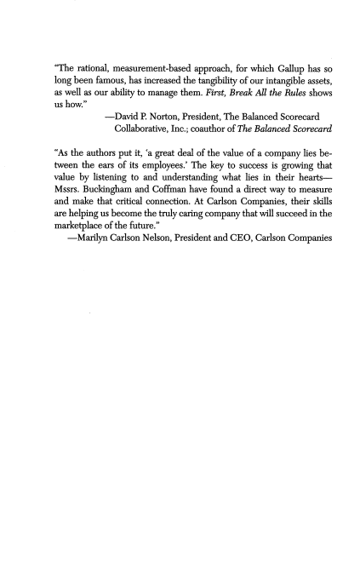
"The rational, measurement-based approach, for which Gallup has so long been famous, has increased the tangibility of ourintangible assets, as well as our ability to manage them. First, Break All the Rules shows us how."
—David P. Norton, President, The Balanced Scorecard Collaborative, Inc.; coauthor of The Balanced Scorecard
"As the authors put it, 'a great deal of the value of a company lies be tween the ears of its employees.' The key to success is growing that value by listening to and understanding what lies in their hearts— Mssrs. Buckingham and Coffman have found a direct way to measure and make that critical connection. At Carlson Companies, their skills are helping us become the trulycaring company that will succeedin the marketplace of the future."
—Marilyn Carlson Nelson, Presidentand CEO, CarlsonCompanies
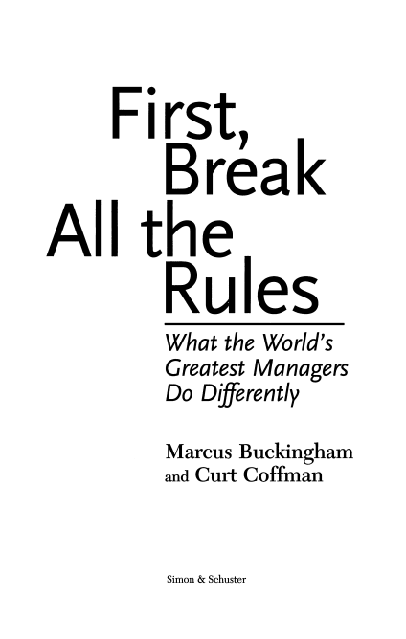
First,
Break
All the
Rules
What the World's
Greatest Managers
Do Differently
Marcus Buckingham
and Curt Coffman
Simon & Schuster
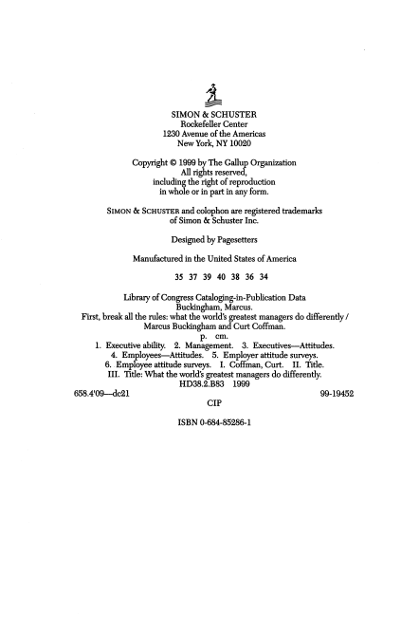
±
SIMON & SCHUSTER
Rockefeller Center
1230 Avenue ofthe Americas
New York, NY 10020
Copyright © 1999 by The Gallup Organization
Allrights reserved,
including the rightofreproduction
in wholeorin partin any form.
Simon & Schuster andcolophon areregistered trademarks of Simon & Schuster Inc.
Designedby Pagesetters
Manufactured in the United States ofAmerica
35 37 39 40 38 36 34
Library ofCongress Cataloging-in-Publication Data
Buckingham, Marcus.
First, breakall the rules: whattheworld s greatest managers do differently / Marcus Buckingham andCurt Coffman.
p. cm.
1. Executive ability. 2. Management. 3. Executives—Attitudes. 4. Employees—Attitudes. 5. Employerattitudesurveys.
6. Employee attitude surveys. I. Coffman, Curt. II. Tide. III. Tide:What the world's greatest managers do differendy. HD38.2.B83 1999
658.4'09—dc21 99-19452 CIP
ISBN 0-684-85286-1
To Janie, whofoundwhat was always there
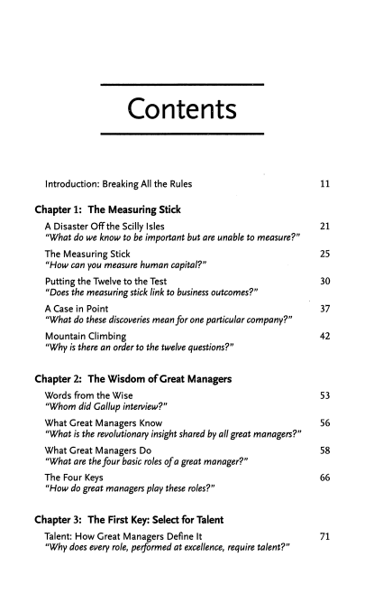
Contents
Introduction: BreakingAll the Rules 11
Chapter 1: The Measuring Stick
A Disaster Off the Scilly Isles 21 "What do we know to be important but are unable to measure?"
The Measuring Stick 25 "How can you measure humancapital?"
Putting the Twelve to the Test 30 "Does the measuring stick link to business outcomes?"
A Case in Point 37 "What do these discoveries meanfor oneparticular company?"
Mountain Climbing 42 "Why isthere an orderto the twelve questions?"
Chapter 2: The Wisdom ofGreat Managers
Words from the Wise 53 "Whom did Gallup interview?"
What Great Managers Know 56 "What isthe revolutionary insight shared by allgreat managers?"
What Great Managers Do 58 "What arethefour basic roles ofa great manager?"
The Four Keys 66 "How do great managers playthese roles?"
Chapter 3: The First Key: Select for Talent
Talent: How Great Managers Define It 71 "Why does everyrole, performed at excellence, require talent?"
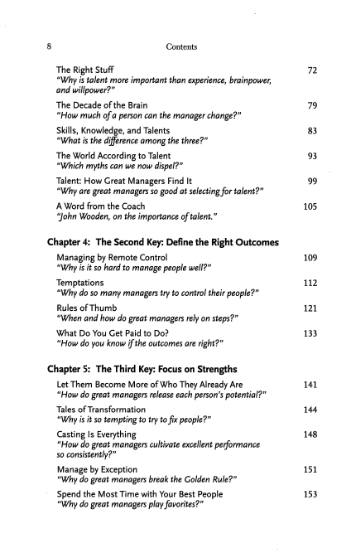
8 Contents
The Right Stuff 72 "Why istalentmore important than experience, brainpower, and willpower?"
The Decade ofthe Brain 79 "How much ofa person can themanager change?"
Skills, Knowledge, and Talents 83 "What isthe difference among the three?"
The World Accordingto Talent 93 "Which myths can we nowdispel?"
Talent: How Great Managers Find It 99 "Why are great managers sogood at selectingfortalent?"
A Word from the Coach 105 "John Wooden, on the importance oftalent"
Chapter 4: The Second Key: Definethe RightOutcomes
Managing by Remote Control 109 "Why is it so hard to manage people well?"
Temptations 112 "Why do so manymanagers tryto control their people?"
Rules ofThumb 121 "When and howdo great managers rely onsteps?"
What Do You Get Paid to Do? 133 "How do you know ifthe outcomes are right?"
Chapter 5: The Third Key: Focus on Strengths
Let Them Become More of Who TheyAlready Are 141 "How do great managers release each person's potential?"
Tales ofTransformation 144 "Why is it so tempting to try tofix people?"
Casting Is Everything 148 "How do great managers cultivate excellent performance
so consistently?"
Manage by Exception 151 "Why do great managers break the Golden Rule?"
Spend the Most Time with Your Best People 153 "Why do greatmanagers playfavorites?"
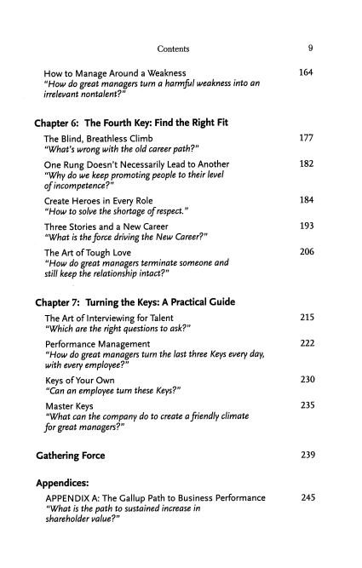
Contents 9
How to Manage Around a Weakness 164 "How do great managers turn a harmful weakness into an irrelevant nontalent?"
Chapter 6: The Fourth Key: Find the Right Fit
The Blind, Breathless Climb 177 "What's wrong with the oldcareer path?"
One Rung Doesn't Necessarily Lead to Another 182 "Why do we keep promoting people to their level
ofincompetence?"
Create Heroes in Every Role 184 "How to solve the shortage ofrespect"
Three Stories and a New Career 193 "What is theforce driving the New Career?"
TheArt ofTough Love 206 "How do great managers terminate someone and
still keep the relationship intact?"
Chapter 7: Turning the Keys: A Practical Guide
The Artof Interviewing forTalent 215 "Which are the right questions to ask?"
Performance Management 222 "How do great managers turn the last three Keys every day, with every employee?"
Keys of Your Own 230 "Can an employee turn these Keys?"
Master Keys 235 "What can the company do to create afriendly climate
for great managers?"
Gathering Force 239
Appendices:
APPENDIX A: The Gallup Path to Business Performance 245 "What is the path to sustained increase in
shareholder value?"
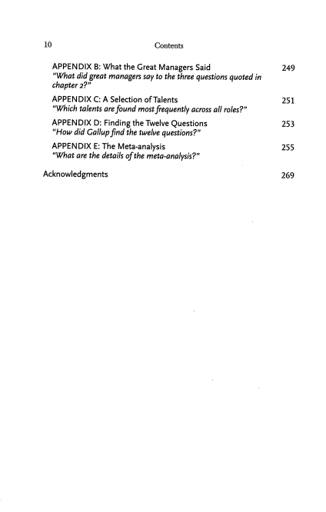
10 Contents
APPENDIX B: What the Great Managers Said 249 "What did great managers say tothe three questions quoted in chapter2?"
APPENDIX C: A Selection ofTalents 251 "Which talents are found mostfrequently across all roles?"
APPENDIX D: Finding the Twelve Questions 253 "How did Gallup find the twelve questions?"
APPENDIX E: The Meta-analysis 255 "What are the details ofthe meta-analysis?"
Acknowledgments 269
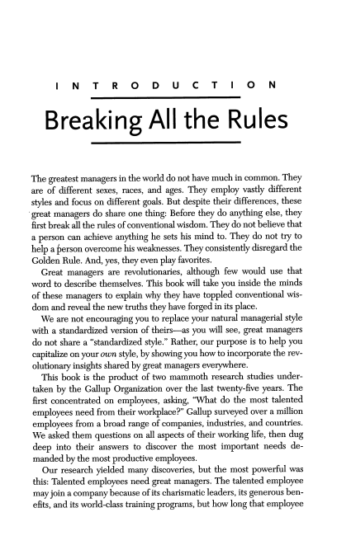
INTRODUCTION Breaking All the Rules
The greatest managers inthe world do not have much incommon. They are of different sexes, races, and ages. They employ vastly different styles and focus ondifferent goals. But despite their differences, these great managers do share one thing: Before they do anything else, they first breakallthe rules ofconventional wisdom. Theydo not believe that a person can achieve anything he sets his mind to. They do not try to help aperson overcome his weaknesses. They consistently disregard the Golden Rule. And, yes, theyevenplay favorites.
Great managers are revolutionaries, although few would use that word to describe themselves. This book will take you inside the minds ofthese managers to explain why they have toppled conventional wis domand reveal the newtruths theyhave forged in its place.
We are not encouraging you to replace your natural managerial style with a standardized version of theirs—as you will see, great managers do notshare a "standardized style." Rather, our purpose is to help you capitalize onyour own style, by showing you how toincorporate the rev
olutionary insights shared bygreat managers everywhere. This book is the product oftwo mammoth research studies under taken by the Gallup Organization over the last twenty-five years. The first concentrated on employees, asking, "What do the most talented employees need from their workplace?" Gallup surveyed over a million employees from a broad range of companies, industries, and countries. We asked them questions on all aspects oftheir working life, then dug deep into their answers to discover the most important needs de manded by the mostproductive employees.
Our research yielded many discoveries, but the most powerful was this: Talented employees needgreat managers. The talented employee may join a company because ofits charismatic leaders, its generous ben efits, anditsworld-class training programs, but how long that employee
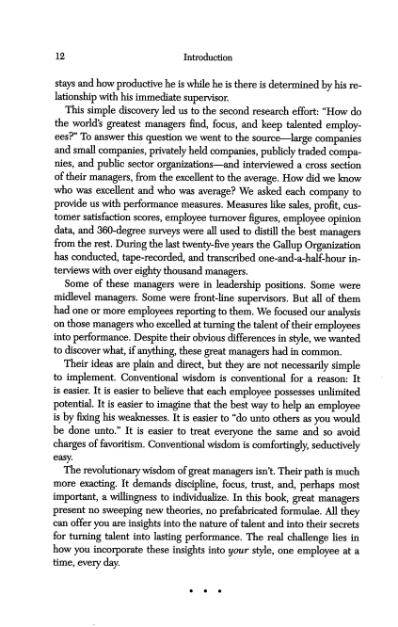
12 Introduction
stays and how productive he is while he is there is determined by his re lationship with his immediate supervisor.
This simple discovery led us to the second research effort: "How do the worlds greatest managers find, focus, and keep talented employ ees?" To answer this question we went to the source—large companies and small companies, privately held companies, publicly traded compa nies, and public sector organizations—and interviewed a cross section oftheir managers, from the excellent to the average. How did we know who was excellent and who was average? We asked each company to provide us with performance measures. Measures like sales, profit, cus tomer satisfaction scores, employee turnover figures, employee opinion data, and 360-degree surveys were all used to distill the best managers from the rest. During the last twenty-five years the Gallup Organization has conducted, tape-recorded, and transcribed one-and-a-half-hour in terviews with over eighty thousand managers.
Some of these managers were in leadership positions. Some were midlevel managers. Some were front-line supervisors. But all ofthem had one ormore employees reporting to them. We focused our analysis on those managers who excelled atturning the talent oftheir employees into performance. Despite their obvious differences instyle, we wanted todiscover what, ifanything, these great managers had incommon.
Their ideas are plain and direct, but they are not necessarily simple to implement. Conventional wisdom is conventional for a reason: It is easier. It is easier to believe that each employee possesses unlimited potential. It is easier toimagine that the best way to help an employee is by fixing his weaknesses. It is easier to"do unto others as you would be done unto." It is easier to treat everyone the same and so avoid charges offavoritism. Conventional wisdom is comfortingly, seductively easy.
The revolutionary wisdom ofgreat managers isn't. Their path is much more exacting. It demands discipline, focus, trust, and, perhaps most important, a willingness to individualize. In this book, great managers present no sweeping new theories, noprefabricated formulae. All they can offeryouare insights intothe nature oftalent and into theirsecrets for turning talent into lasting performance. The real challenge lies in how you incorporate these insights into your style, one employee at a time, everyday.
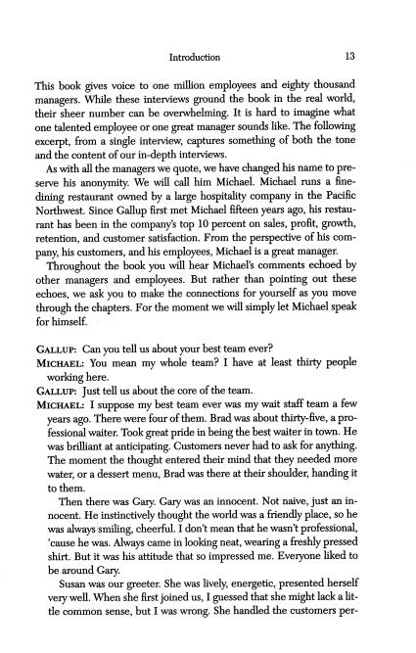
Introduction 13
This book gives voice to one million employees and eighty thousand managers. While these interviews ground the book in the real world, their sheer number can be overwhelming. It is hard to imagine what one talented employee orone great manager sounds like. The following excerpt, from a single interview, captures something of both the tone and the content of our in-depth interviews.
As with all the managers wequote, we have changed his name to pre serve his anonymity. We will call him Michael. Michael runs a fine dining restaurant owned by a large hospitality company in the Pacific Northwest. Since Gallup first metMichael fifteen years ago, his restau
rant has been in the company's top 10 percent on sales, profit, growth, retention, and customer satisfaction. From the perspective of his com pany, his customers, and his employees, Michael isa great manager.
Throughout the book you will hear Michael's comments echoed by other managers and employees. But rather than pointing out these echoes, we ask you to make the connections for yourself as you move through the chapters. For the moment we will simply letMichael speak
for himself.
Gallup: Canyou tellus about your bestteam ever?
Michael: You mean my whole team? I have at least thirty people working here.
Gallup: Justtellus about the core ofthe team.
Michael: I suppose my best team ever was my wait staff team a few years ago. There were four ofthem. Brad was about thirty-five, apro fessional waiter. Took greatpridein beingthe bestwaiterin town. He was brilliant at anticipating. Customers never hadto ask for anything. Themoment the thought entered theirmind that they needed more water, or a dessert menu, Bradwasthere at their shoulder, handing it
to them.
Then there was Gary. Gary was an innocent. Not naive, just an in nocent. He instinctively thought theworld was a friendly place, sohe was always!smiling, cheerful. I don't mean that he wasn't professional, 'cause hewas. Always came inlooking neat, wearing a freshly pressed shirt. Butit was his attitude that soimpressed me. Everyone liked to be around Gary.
Susan was our greeter. She was lively, energetic, presentedherself very well. When she first joined us, I guessed that she might lack alit tle commonsense, but I was wrong. She handled the customersper-
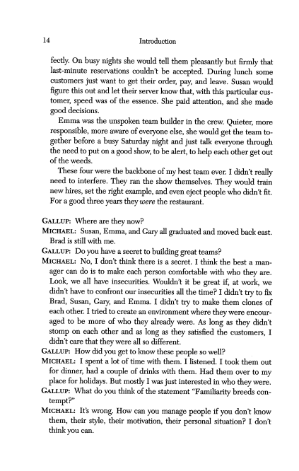
14 Introduction
fectly On busy nights she would tell them pleasantly but firmly that last-minute reservations couldn't be accepted. During lunch some customers just want to get their order, pay, and leave. Susan would figure this out and lettheir server know that, with this particular cus
tomer, speed was of the essence. She paid attention, and she made good decisions.
Emma was the unspoken team builder in the crew. Quieter, more responsible, more aware ofeveryone else, she would get theteam to gether before a busy Saturday night and just talk everyone through the need toput on agood show, to bealert, tohelp each other get out ofthe weeds.
These four were the backbone ofmy best team ever. I didn't really need to interfere. They ran the show themselves. They would train new hires, set the right example, and even eject people who didn't fit. For a good three years theywere the restaurant.
Gallup: Where are theynow?
Michael: Susan, Emma, andGary all graduated andmoved backeast. Brad is still with me.
Gallup: Doyou have a secret tobuilding great teams? Michael: No, I don't think there is a secret. I think the best a man ager can do is to make each person comfortable with who they are. Look, we all have insecurities. Wouldn't it be great if, at work, we didn't have to confront our insecurities all the time? I didn't try tofix Brad, Susan, Gary, and Emma. I didn't try to make them clones of each other. I tried tocreate anenvironment where they were encour aged to be more of who they already were. As long as they didn't stomp on each other and as long as they satisfied the customers, I didn'tcarethat theywereallsodifferent.
Gallup: Howdidyou get to know thesepeople sowell? Michael: I spent a lot of time with them. I listened. I took them out for dinner, had a couple ofdrinks with them. Had them over to my place for holidays. But mostly I was just interested inwho they were. Gallup: What doyou think ofthe statement "Familiarity breeds con tempt?"
Michael: It's wrong. Howcan you manage people if you don't know them, their style, their motivation, their personal situation? I don't think you can.
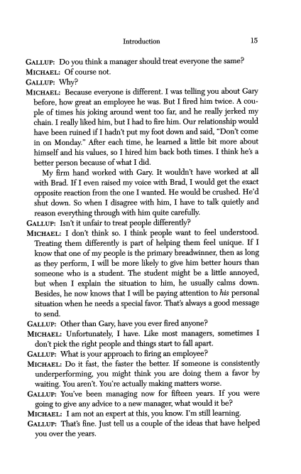
Introduction 15
Gallup: Do you think amanager should treat everyone thesame? Michael: Of course not.
Gallup: Why?
Michael: Because everyone is different. I was telling you about Gary before, how great an employee he was. But I fired him twice. Acou ple oftimes his joking around went too far, and he really jerked my chain. I really liked him, butI had tofire him. Our relationship would have been ruinedif I hadn't put my foot down andsaid, "Don'tcome in on Monday." After each time, he learned a little bit more about himself and his values, so I hired him back both times. I think he's a better person because ofwhat I did.
My firm hand worked with Gary. It wouldn't have worked at all with Brad. If I even raised my voice with Brad, I would get the exact opposite reaction from the one I wanted. He would becrushed. He'd shut down. So when I disagree with him, I have to talk quietly and reason everything through with him quite carefully.
Gallup: Isn'tit unfair to treat people differendy?
Michael: I don't think so. I think people want to feel understood. Treating them differently is part of helping them feel unique. If I know that oneofmy people isthe primary breadwinner, then as long as they perform, I will be more likely to give him better hours than someone who is a student. The student might be a little annoyed, but when I explain the situation to him, he usually calms down. Besides, he now knows that I will be paying attention to his personal situation when he needs a special favor. That's always a good message
to send.
Gallup: Otherthan Gary, have you ever fired anyone? Michael: Unfortunately, I have. Like most managers, sometimes I don'tpick the right people andthings startto fall apart. Gallup: What isyour approach to firing anemployee? Michael: Do it fast, the faster the better. If someone is consistently underperforming, you might think you are doing them a favor by waiting. You aren't. You're actually making matters worse. Gallup: You've been managing now for fifteen years. If you were going to give any advice to a new manager, what would it be? Michael: I amnot an expert at this, you know. I'm still learning. Gallup: That's fine. Justtell us a couple ofthe ideas that have helped you over the years.
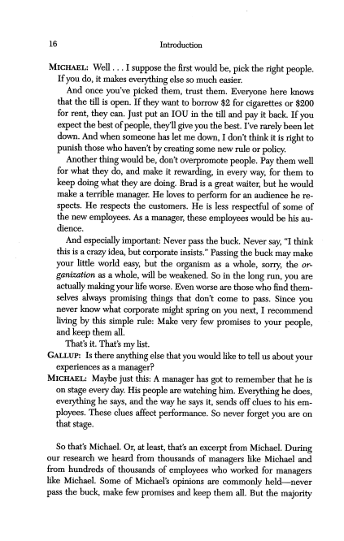
16 Introduction
Michael: Well... Isuppose the first would be, pick the right people. Ifyou do, it makes everything else so much easier.
And once you've picked them, trust them. Everyone here knows that the till is open. Ifthey want toborrow $2 for cigarettes or $200 for rent, they can. Just put an IOU in the till and pay it back. Ifyou expect the best ofpeople, they'll give you the best. I've rarely been let down. And when someone has let me down, I don't think itis right to punish those who haven't by creating some new rule orpolicy.
Another thing would be, don't overpromote people. Pay them well for what they do, and make it rewarding, in every way, for them to keep doing what they are doing. Brad is a great waiter, buthewould make a terrible manager. He loves toperform for an audience he re
spects. He respects the customers. He isless respectful of some of the new employees. As a manager, these employees would be his au dience.
And especially important: Never pass the buck. Never say, "Ithink this is acrazy idea, but corporate insists." Passing the buck may make your little world easy, but the organism as a whole, sorry, the or ganization as a whole, will beweakened. So in the long run, you are actually making yourlifeworse. Evenworse are thosewhofindthem
selves always promising things that don't come to pass. Since you never know what corporate might spring onyou next, I recommend living by this simple rule: Make very few promises to your people, and keepthem all.
That's it. That's mylist.
Gallup: Isthere anything else that you would like totell us about your experiences as a manager?
Michael: Maybe justthis: Amanager has gotto remember that he is onstage every day. His people are watching him. Everything he does, everything he says, and the way he says it,sends offclues to his em ployees. These clues affect performance. So never forget you are on that stage.
So that's Michael. Or, atleast, that's an exceipt from Michael. During our research we heard from thousands of managers like Michael and from hundreds ofthousands of employees who worked for managers like Michael. Some of Michael's opinions are commonly held—never pass the buck, make few promises and keep them all. But the majority
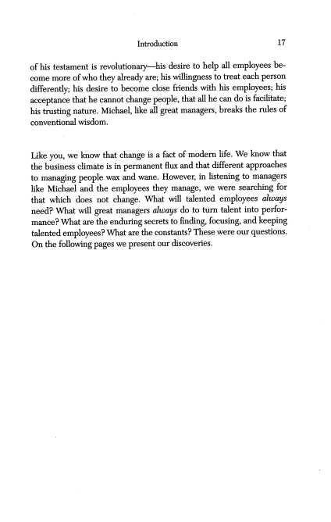
Introduction 17
of his testament isrevolutionary—his desire to help all employees be come more ofwho they already are; his willingness totreat each person differently; his desire to become close friends with his employees; his acceptance that he cannot change people, that all he can do is facilitate; his trusting nature. Michael, like all great managers, breaks the rules of
conventional wisdom.
Like you, we know that change is a fact ofmodern life. We know that thebusiness climate is inpermanent flux and that different approaches to managing people wax and wane. However, in listening to managers like Michael and the employees they manage, we were searching for that which does not change. What will talented employees always need? What will great managers always do to turn talent into perfor mance? What are theenduring secrets tofinding, focusing, and keeping talented employees? What are theconstants? These were ourquestions. Onthe following pages we present ourdiscoveries.
CHAPTER 1
The Measuring Stick
• A Disaster OfTthe Scilly Isles
• The Measuring Stick
• Putting the Twelve to the Test
• A Case in Point
• Mountain Climbing
A Disaster Offthe Scilly Isles
"What do we know to be important butare unable to measure?"
In the dense fog of a dark night in October 1707, Great Britain lost nearly an entire fleet ofships. There was no pitched battle atsea. The admiral, Clowdisley Shovell, simply miscalculated his position in the Atlantic and his flagship smashed into the rocks ofthe Scilly Isles, a tail ofislands offthe southwest coast ofEngland. The rest ofthe fleet, fol
lowing blindly behind, went aground and piled onto the rocks, one after another. Fourwarships andtwo thousand lives were lost. For such a proud nation ofseafarers, this tragic loss was distincdy embarrassing. But tobe fair tothememory ofClowdisley Shovell, itwas not altogether surprising. The concept oflatitude and longitude had beenaround since the first century B.C. But by1700 westill hadn't man aged to devise an accurate way to measure longitude—nobody ever knew for sure how far eastor west theyhad traveled. Professional sea men like Clowdisley Shovell had to estimate their progress either by guessing their average speed or by dropping a log over the side ofthe boat and timing how long it took to float from bow to stern. Forced to rely on such crude measurements, the admiral can be forgiven his mas sive misjudgment.
Whatcausedthe disaster was not the admiral's ignorance, but his in ability to measure something that he already knew to be critically im portant—in this case longitude.
Asimilar drama isplaying outintodays business world: many compa nies know that their ability to find and keep talented employees isvital to theirsustained success, but theyhave noway ofknowing whether or not they are effective at doingthis.
In their book The Service Profit Chain, James Heskett, W. Earl Sasser, and Leonard Schlesinger make the case that no matter what your business, the only way to generate enduring profits is to begin by building the kind ofwork environment that attracts, focuses, andkeeps talented employees. It is a convincing case. But the manager on the street probably didn'tneed convincing. Over the lasttwenty years most managers have come to realize their competitiveness depends upon
22 THE MEASURING STICK
being able to find and keep top talent in every role. This is why, in tight labor markets, companies seem prepared to go to almost any lengths to prevent employees' eyes from wandering. Ifyou work for GE, you may be one ofthe twenty-three thousand employees who are now granted stock options inthecompany. Employees ofAlliedSignal and Starbucks can make use ofthe company concierge service when they forget that their mothers need flowers and their dachshunds need walking. And at Eddie Bauer, in-chair massages are available for all those aching backs hunched over computer terminals.
But do any ofthese caring carrots really work? Do they really attract and keep only the most productive employees? Or are they simply a catch-all, netting both productive employees and ROAD warriors—the army's pithy phrase for those sleepy folk who are happy to "retire onac
tiveduty"?
The truth is, no one really knows. Why? Because even though every great manager and every great company realizes how important it is, they still haven't devised an accurate way to measure a manager's or a company's ability tofind, focus, and keep talented people. The few mea
surements that are available—such as employee retention figures or number ofdays tofill openings orlengthy employee opinion surveys— lack precision. They are the modern-day equivalent ofdropping a log over the side ofthe boat.
Companies and managers know they need help. What they are asking for isa simple and accurate measuring stick thatcan tell them how well one company or one manager is doing as compared with others, in terms offinding and keeping talented people. Without this measuring stick, many companies and many managers know they may find them
selves high and dry—sure ofwhere they want togo but lacking the right people to get there.
And now there is a powerful new faction on the scene, demanding thissimple measuring stick: institutional investors.
Institutional investors—like the Council of Institutional Investors (CII),which manages over$1trillion worthofstocks, and the California Public Employees Retirement System (CalPERS), which oversees a healthy $260 billion—define the agenda for the business world. Where they lead, everyone else follows.
Institutional investors have always been the ultimate numbers guys, representing the cold voice of massed shareholders, demanding effi-
A DisasterOffthe Scilly Isles 23
ciency and profitability. Traditionally they focused on hard results, like return on assets and economic value added. Most of them didn't con cern themselves with "soft" issues like "culture." In their minds a company's culture held the same status as public opinion polls did in
Soviet Russia: superficially interesting butfundamentally irrelevant. At least that's the way it used to be. In a recent about-face, they have started to pay much closer attention to how companies treat their people. In fact, the CII and CalPERS both met inWashington to dis cuss "good workplace practices .. . and how they can encourage the companies they invest in tovalue employee loyalty as anaid to produc tivity."
Why this newfound interest?They have started torealize thatwhether software designer or delivery truck driver, accountant or hotel house keeper, themost valuable aspects ofjobs are now, as Thomas Stewart de scribes in Intellectual Capital, "the most essentially human tasks: sensing, judging, creating, and building relationships." This means thata great deal ofa company's value now lies "between theears ofits employ ees."Andthis meansthat when someone leaves a company, he takeshis value withhim—more oftenthan not,straight to the competition.
Today more than ever before, if a company is bleeding people, it is bleeding value. Investors are frequently stunned bythis discovery. They know that their currentmeasuring sticks do a very poorjob of capturing all sources ofa company's value. For example, according to Baruch Lev, professor of finance and accounting at New York University's Stern School of Business, the assets and liabilities listed on a company's bal ance sheetnow account for only 60percent ofitsrealmarket value. And this inaccuracy isincreasing. In the 1970s and 1980s, 25percent of the changes in a company's market value could be accounted for byfluctua
tions in its profits. Today, according to Professor Lev, that number has shrunk to 10 percent.
The sources of a company's true value have broadenedbeyondrough measures of profit or fixed assets, and bean counters everywhere are scurrying to catch up. Steve Wallman, former commissioner of the Securities and Exchange Commission, describes what they are looking for:
If we start to get further afield so that the financial statements... are measuring less and less of what istruly valuable in a company, then we
24 THE MEASURING STICK
start to lower the relevance ofthat scorecard. What we need are ways to measure the intangibles, R&D, customer satisfaction, employee satisfac tion, (italics ours)
Companies, managers,institutionalinvestors, even the commissionerof theSEC—everywhere you look, people are demanding a simple and ac curate measuring stick for comparing the strength of oneworkplace to another. The Gallup Organization set out to buildone.
The Measuring Stick
"How can you measure human capital?"
Whatdoes a strong, vibrant workplace look like?
When you walk into the building at Lankford-Sysco a few miles up the road from Ocean City, Maryland, it doesn't initially strike you as a special place. In fact, itseems slightly odd. There's theunfamiliar smell: a combination of raw food and machine oil.There's the decor: row upon row ofshelving piled high to the triple ceilings, interspersed with the occasional loading dock or conveyor belt. Glimpses of figures bundled up in arctic wear, lugging mysterious crates in andoutofdeepfreezers, onlyadd to your disquiet.
But you press on, and gradually you begin to feel more at ease. The employees you run into are focused andcheerful. On the way to recep tion you pass a huge mural thatseems to depict the history ofthe place: "There's Stanley E. Lankford Jr. hiring the first employee. There's the original office building before we added the warehouse. . . ." In the re ception area you face a wall festooned with pictures ofindividual, smil ing faces. There are dozens of them, each with an inscription underneath that lists theirlength ofservice with the company and then
another number.
"They are our delivery associates," explains Fred Lankford, the presi dent. "We put theirpicture upsothatwe can all feel close to them, even though they're out with our customers every day. The number you see under eachpicture represents the amount ofmiles that eachone drove lastyear. We like to publicize eachperson's performance."
Stanley Lankford and his three sons (Tom, Fred, and Jim) founded the Lankford operation, a family-owned food preparation and distribu tioncompany, in 1964. In 1981 theymerged with Sysco, the $15 billion food distribution giant. An important proviso was that Tom, Fred, and Jim would be allowed to stay on as general managers. Sysco agreed, and todayallpartiescouldn'tbe happierwiththe decision.
The Lankford-Sysco facility isin the top 25percentof all Sysco facili ties in growth, sales per employee, profit per employee, and market penetration. They have single-digit turnover, absenteeism is at an all company low, and shrinkage is virtually nonexistent. Most important,
26 THE MEASURING STICK
the Lankford-Sysco facility consistendy tops the customer satisfaction charts.
"Howdo youdo it?"youaskFred.
He says there is not much to it. He is pleased with his pay-for performance schemes—everything is measured; every measurement is posted; and every measurement has some kind of compensation at tached. But he doesn't offer that up as his secret. Hesays itis just daily work. Talk about the customer. Highlight the right heroes. Treat people with respect. Listen.
His voice trails off because he sees he is not giving you the secret recipe youseemto be looking for.
Whatever he's doing, it clearly works for his employees. Forklift oper ators tell you about their personal best in terms of "most packages picked" and"fewest breakages." Drivers regale you with theirstories of rushing out an emergency delivery of tomato sauce to a restaurant caught short. Everywhere you turn employees are talking about how their Httle part oftheworld is critical togiving the customer thequality that is now expected from Lankford-Sysco.
Here are 840 employees, all ofwhom seem to thrill to the challenge of theirwork. Whatever measurements you care to use, the Lankford Sysco facility in Pocomoke, Maryland, isa great place towork.
You will have your own examples of a work environment that seems to be firing onall cylinders. It will be a place where performance levels are consistently high, where turnover levels are low, and where a grow ing number ofloyal customers join the fold every day.
With your real-life example in mind, the question you have to ask yourself is, "What lies at the heartofthis great workplace? Which ele ments will attract only talented employees andkeep them, andwhich el ements are appealing to every employee, the best, the rest, and the ROAD warriors?"
Do talented employees really care how empowered theyare, as long as they are paid on performance, such as at Lankford-Sysco? Perhaps the opposite is true; once their most basic financial needs have been met, perhaps talented employees care less about payand benefits than they do about being trusted by theirmanager. Are companies wasting theirmoney byinvesting in spiffier work spaces andbrighter cafeterias? Or do talented employees value a clean and safe physical environment above all else?
To buildourmeasuring stick, we hadto answer thesequestions.
The Measuring Stick 27
Over the last twenty-five years the Gallup Organization has interviewed more than a million employees. We have asked each ofthemhundreds ofdifferent questions, onevery conceivable aspect oftheworkplace. As you can imagine, one hundred million questions is a towering haystack of data. Now, we had to siftthrough it,straw bystraw, and find the nee dle. We had to pickout those few questions that were trulymeasuring the core of a strongworkplace.
This wasn't easy. If you have a statistical mind, you canprobably haz arda pretty good guess as to how we approached it—a combination of focus groups, factor analysis, regression analysis, concurrent validity studies, and follow-up interviews. (Our research approach is described in detailin the appendix.)
However, if you think statistics are the mental equivalent of drawing your fingernails across a chalkboard, the following image may help you envision what we were tryingto do.
In 1666 Isaac Newton closed the blinds of his house in Cambridge and sat in a darkened room. Outside, the sun shone brighdy. Inside, Isaac cut a small hole in one of the blinds and placed a glass prism at the entrance. As the sun streamed through the hole, it hit the prism and a beautiful rainbow fanned out on the wall in front of him. Watching the perfect spectrum of colors playing on his wall, Isaac realized that the prism had pried apart the white light, refracting the colors to different degrees. He discovered that white fight was, in fact, a mixture of all the other colors in the visible spectrum, from dark red to deepest purple; and that the only way to create white light was to draw all of these different colors together into a single
beam.
Wewantedourstatistical analyses to perform the same trickasIsaac's prism. We wanted them to pry apart strong workplaces to reveal the core. We could then sayto managers and companies, "If you can bring allof these core elements togetherin a single place, then youwill have createdthe kindofworkplace that canattract, focus, and keepthe most talented employees."
So we took our mountain of data and we searched for patterns. Which questions were simply different ways ofmeasuring the samefac tor? Whichwere the best questions to measureeach factor? Weweren't particularly interested in those questions that yielded a unanimous,
28 THE MEASURING STICK
"Yes, I strongly agree!" Nor were we swayed bythose questions where everyone said, "No, I strongly disagree." Rather, we were searching for those special questions where themost engaged employees—those who were loyal and productive—answered positively, and everyone else— theaverage performers and the ROAD warriors—answered neutrally or negatively.
Questions that we thought were a shoo-in—like those dealing with payand benefits—fell under the analytical knife. At the same time, in nocuous little questions—such as "Do I know what is expected ofmeat work?"—forced their way to the forefront. We cut and we culled. We rejigge(l andreworked, digging deeper and deeper to find the core ofa greatworkplace.
When the dust finally settled, we made a discovery: Measuring the strength of a workplace can be simplified to twelve questions. These twelve questions don't capture everything you may want to know about your workplace, but theydo capture the most information and the most important information. Theymeasure the core elements needed to at
tract, focus, andkeep themost talented employees.
Here they are:
1. Do I know whatis expected of me at work?
2. Do I have the materials and equipment I need to do my work right?
3. At work, do I have the opportunity to do what I do best every day?
4. In the last seven days, have I received recognition or praise for doinggoodwork?
5. Does my supervisor, or someone at work, seem to care about me as a person?
6. Is there someone at work who encourages mydevelopment? 7. Atwork, do myopinions seem to count?
8. Does the mission/purpose ofmy company make me feel my job is important?
9. Are myco-workers committed to doing quality work? 10. Do I have a best friend at work?
11. In the last six months, has someone at work talked to me about myprogress?
12. This last year, have I hadopportunities atwork tolearn andgrow?
The Measuring Stick 29
These twelve questions are the simplest and most accurate way to measure the strengthof a workplace.
When we started this researchwe didn't know we were going to land on these twelve questions. But after running a hundred million ques tions through our "prism," these exact questions were revealed as the most powerful. If you can create the kind of environment where em ployees answer positively to all twelve questions, then you will have built a great placeto work.
While atfirst glance these questions seem rather straightforward, the more you look at them, the more intriguing theybecome. First, you probably noticed that many ofthe questions contain an ex treme. "I have a bestfriend at work" or "Atwork I have the opportunity to do what I do best every day." When the questions are phrased like this, it ismuch more difficult to say "Strongly Agree," or "5" ona scale of 1 to 5. Butthisis exactly what wewanted. We wanted to find questions that would discriminate between the most productive departments and the rest. We discovered that if you removed the extreme language, the question lost much ofits power todiscriminate. Everyone said "Strongly Agree"—the best, the rest, andeveryone in between. Aquestion where everyone always answers "Strongly Agree" isa weak question. Much ofthepower ofthis measuring stick, then, lies inthewording of the questions. The issues themselves aren't a big surprise. Most people knew, for example, that strong relationships and frequent praise were vital ingredients ofa healthy workplace. However, they didn't know how to measure whetheror not these ingredients were present, and ifso, to what extent. Gallup has discovered the bestquestions to dojustthat. Second, you may be wondering why there are no questions dealing with pay, benefits, senior management, or organizational structure. There were initially, but they disappeared during the analysis. This doesn't mean they are unimportant. It simply means they are equally important to every employee, good, bad, andmediocre. Yes, if you are paying 20percent below the market average, you may have difficulty at tracting people. But bringing yourpayand benefits package up to mar ket levels, while a sensible first step, will not take you very far. These landsofissues are liketickets to the ballpark—they can get youinto the game, but they can't help youwin.
Putting the Twelve to the Test
"Does the measuring stick link to business outcomes?"
Gallup hadsetoutto devise away to measure strong workplaces: work places thatwould attract and retain themost productive employees and scare away the ROAD warriors. If thesequestions werein truth the best questions, then employees who answered them positively would pre sumably work in higher-performing departments. That was our goal when we designed the measuring stick. Would it prove to be true in practice?
Throughout the spring andsummer of 1998 Gallup launched a mas sive investigation to find out.
We asked twenty-four different companies, representing a cross sec tion of twelve distinct industries, to provide us with scores measuring four different kinds ofbusiness outcome: productivity, profitability, em ployee retention, and customer satisfaction. Some companies had diffi culty gathering this data, but in the end we managed to include over 2,500 business units in ourstudy. The definition ofa "business unit"var ied byindustry: forbanking it was the branch; for hospitality it was the restaurant or the hotel; formanufacturing it was the factory; and so on.
We then interviewed the employees who worked in these branches, restaurants, hotels, factories, and departments, asking them to respond to each of the twelve questions on a scale of 1 to 5, "1" being strongly disagree, "5" beingstrongly agree. One hundred and five thousandem
ployees tookpart.
Armed with all this data, we were setto go. We knew the productivity, the profitability, the retention levels, andthe customer ratings of these different business units. And we knew howthe employees of the busi ness units hadanswered the twelve questions. We could now see,finally, whether or not engaged employees did indeed drive positive business outcomes, across 2,500business units and24 companies.
We were optimistic that the linkswould surface, but, truth be told, it was entirely possible that we wouldn't find them. The links between employee opinion and business unit performance seem inevitable— after all, mostof us have probably heard ourselves rattle offsuchcliches as "Happy employees aremore productive" or "Ifyou treat yourpeople
Puttingthe Twelve to the Test 31
right, they will treat your customers right." Yet in their attempts to prove these statements, researchers have frequently come up empty handed. In fact, in moststudies, ifyoutest one hundred employee opin ion questions, you will be lucky to find five or six that show a strong
relationship to anybusiness outcome. Disappointingly, if yourepeat the study, you often find that a different set of five or six questions pop up the second time around.
We also knewthat no one had ever undertaken this kind of study be fore, across many different companies. Since eachofthese fourbusiness outcomes—productivity, profit, retention, and customerservice—is vi tally important to every company, and since the easiest leverfor a man agerto pullis the employee lever, you would have thoughtthe airwould
be thick with research examining the links between employee opinion and these four business outcomes. It isn't. You can track down research examining these links within a particular company—with decidedly mixed results—but neveracross companies and industries. Surprisingly, the Gallup research was the first cross-industry study to investigate the links between employee opinion and business unit performance.
Why does this research vacuum exist? More than likely it's because each company has different ways of measuring the same thing. Blockbuster Video mightmeasure productivity by sales per square foot. Lankford-Sysco might use packages shippedand number of breakages. The Walt DisneyCompany might include only full-time employees in their retention figures. Marriott mightinclude full-time and part-time. It is frustratingly difficult to pick up on linkages between employee opinionand business performance, when everycompany insists on mea
suringperformance differently.
Fortunately we had discovered a solution: meta-analysis. A detailed explanation can put even the most ardent number cruncher to sleep, so let'sjust saythat it is a statistical technique that cuts through the differ ent performance measures used by different companies and allows you to zero in on the real linksbetween employeeopinion and business unit performance.
So, having entered the performance data from over 2,500 business units and punched in the opiniondata from over 105,000 employees, we programmed the meta-analysis formulas, pressed Run, and held our breath.
This is what we found. First, we saw that those employees who re-
32 THE MEASURING STICK
sponded morepositively to the twelve questions also worked in business units with higher levels of productivity, profit, retention, and customer satisfaction. This demonstrated, for the first time, the link between em ployee opinion and business unit performance, across many different companies.
Second, the meta-analysis revealed that employees rated the ques tions differently depending on which business unit they worked for rather than which company. This meant that, for the most part, these twelve opinions werebeing formed bythe employees' immediate man ager rather than by the policies or procedures of the overall company. We had discovered that the manager—not pay, benefits, perks, or a charismatic corporate leader—was the critical player in building a strong workplace. Themanager was the key. We will discuss this finding in more detaillater in the chapter. For nowlet's concentrateon our first discovery, the link between employee opinion andbusiness unit perfor mance.
THE LINKS BETWEEN EMPLOYEE OPINION AND BUSINESS UNIT PERFORMANCE
If you are so inclined, you can find in the appendix a detailed descrip tionofallour discoveries andthe methodology behindthem.This is the top line.
• Everyone of the twelve questions was linkedto at least one of the four business outcomes: productivity, profitability, retention, and customersatisfaction. Most of the questions revealed links to two or more business outcomes. The twelve questions were indeed capturing those few, vital employee opinions that related to top performance, whether in a bank, a restaurant, a hotel, a factory, or anyother kindofbusiness unit. The measuring stick hadwithstood its most rigorous test.
• As you might have expected, the most consistent links (ten of the twelve questions) were to the "productivity" measure. People have always believedthere is a direct link between an employee's opin ion and his work group's productivity. Nonetheless, it was good to see the numbersjibe with the theory.
Puttingthe Twelve to the Test 33
Eight of the twelve questions showed a link to the "profitability" measure. That means employees who answered these eight ques tions more positively than other employees also worked in more profitable banks, restaurants, hotels, factories, or departments. To some peoplethismight seema little surprising. After all, many be lieve that profit is a function offactors that fie far beyond the con trol of individual employees: factors like pricing, competitive positioning, or variable-cost management. But the more you think about it, the more understandable this link becomes. There are so many things one employee can do to affect profit—everything from turning off more lights, to negotiating harder on price, to avoiding the temptations of the till. Simply put, these will happen
more often when each employee feels trulyengaged. What about employee retention?Strangely enough, onlyfive of the twelve questionsrevealeda linkto retention:
1. Do I knowwhat is expectedof me at work?
2. Do I havethe materials and equipment I need to do mywork right?
3. Do I havethe opportunity to do what I do best everyday? 5. Does my supervisor, or someone at work, seem to care about me as a person?
7. Atwork, do myopinions seem to count?
Most people would instinctively agree with the generalization "Engaged employees will stay longer." But our research suggests that the link between employee opinion and employee retention is subtler and more specific than this kind of generalization has al
lowed. Even more than the rest, these five questions are most di rectly influenced by the employee's immediate manager. What does this tell us? It tellsus that people leave managers, not compa nies. So much moneyhas been thrown at the challenge of keeping good people—in the form of better pay, better perks, and better training—when, in the end, turnover is mostly a manager issue. If
you have a turnoverproblem, look first to yourmanagers. Of the twelve, the mostpowerful questions are thosewith a combi nationof the strongest links to the most business outcomes. Armed with this perspective, we nowknow that the following six are the most powerful questions:
1. Do I knowwhat is expectedof me at work?
34 THE MEASURING STICK
2. Do I have the materials andequipmentI need to do mywork right?
3. Do I have the opportunity to dowhat I dobest every day? 4. In the lastseven days, have I received recognition or praise for goodwork?
5. Does my supervisor, or someone at work, seem to care about me as a person?
6. Is there someone at work who encourages mydevelopment?
As amanager, ifyouwanttoknow whatyoushould doto builda strong andproductive workplace, securing 5's tothesesix questions would be an excellent place to start. We will return to these questions in a moment.
MANAGERS TRUMP COMPANIES
Once a year a studyis published entitled "The Hundred Best Compa nies to Work For." The criteria for selection are such factors as Does the company have an on-site daycare facility? Howmuchvacation doesthe company provide? Does the company offer anykind of profitsharing? Is the company committed to employee training? Companies are exam
ined, and the listof the top one hundred is compiled.
Our research suggests that these criteria miss the mark. It's not that these employee-focused initiatives are unimportant. It's just that your immediate manager is more important. She defines and pervades your work environment. If she sets clearexpectations, knows you, trusts you, and invests in you, then youcan forgive the company its lackof a profit sharing program. But if your relationship with your manager is frac
tured, then no amountofin-chair massaging or company-sponsored dog walking willpersuade you to stayand perform. It is better to work for a great managerin an old-fashioned company than for a terrible manager in a companyoffering an enlightened, employee-focused culture.
SharonF, a graduateof Stanford and Harvard, leftAmerican Express a litde over a year ago. Shewantedto get into the world of publishing, so she joined one of the media-entertainment giants in the marketing department of one of their manymagazines. She wasresponsiblefor de
vising loyalty programs to ensure that subscription holders would renew. She lovedthe work, excelled at it, and caught the eye of senior
Putting the Twelve to the Test 35
management. Sharon is a very small cog in this giant machine, but ac cording to the chairman of this giant, employees like her—bright, tal ented, ambitious employees—are "the fuel for our future."
Unfortunately for this giant, the fuel is leaking. After only a year Sharon is leaving the company. She is joining a restaurant start-up as head of marketing and business development. Her boss, it appears, drove her away.
"He's not a bad man," she admits. "He'sjust not a manager. He's inse cure, and I don't think you can be insecure and a good manager. It makes him compete with his ownpeople. It makes him boast about his high-style living, when he should be listening to us. And he plays these silly little power games to show us who's the boss. Like last week he didn't showup for a ten a.m.interview witha candidatewhohad made a two-hourcommutejust to see him,becausehe had stayedout much too late the night before. He called me at nine fifty-five a.m., asked me to break the news to her, and tried to make it seem like he was giving me somekindof compliment, that he couldreally trust me to coverfor him. I can't stand behavior like that."
Listening to Sharon, you mightwonderif it is just a personality clash or even whether it is she who issomehow causing the problems. Soyou askher, "Does anyoneelse on the team feel the sameway?"
"I'm not sure," she confesses. "I don't liketo bad-mouth my boss, so I haven't reallytalked about it with anyone at work. But I do know this: When I came here there were thirteen of us on his team. Now, a year later,everysingle one of them has left, exceptme."
Sharon's company does many things very well, both in terms of its overall business performance and its employee-friendly culture. But deep within this giant, unseen by the senior executives or Wall Street, one individual is draining the company of power and value. As Sharon says, he is not a bad man, but he is a bad manager. Woefully miscast, he now spends his days chasing away one talented employee after another.
Perhaps he is an exception. Or perhaps the giant makes a habit of promoting people into manager roles who are talented individual achievers but poor managers. The giant would certainly hope for the former. But Sharon doesn't care one way or the other. When she told her company that she was considering leaving, they offered her more money and a bigger title, to try to coax her back. But they didn't offer her what she wanted most: a newmanager. Soshe left.
36 THE MEASURING STICK
An employee mayjoin Disney or GE or TimeWarnerbecause she is lured by their generous benefits package and their reputation for valu ing employees. But it is her relationship with her immediate manager that will determine how long she stays and how productive she is while she isthere. Michael Eisner, JackWelch, GeraldLevin, and allthe good will in the worldcan do onlysomuch. In the end these questions tell us that, fromthe employee s perspective, managers trump companies.
Unlike Wall Street and the business press, employees don't put their faith in the myth of "great companies" or "greatleaders." For employ ees, there are only managers: great ones, poor ones, and many in be tween. Perhaps the best thing any leader can do to drive the whole company toward greatness is, first, to hold each manager accountable for what his employees say to these twelve questions, and, second, to help each manager know what actions to take to deserve "Strongly Agree" responses from his employees.
The following chaptersdescribe the actions taken by the worlds great managers.
Butfirst, a casein point: Whatdo allthese discoveries mean for a spe cific company or a specific manager?
A Case in Point
"What do these discoveries meanfor one particular company?"
In the winter of 1997 Gallup was asked by an extremely successful re tailer to measure the strength of their work environment. They em ployed thirty-seven thousand people spread across three hundred stores—about one hundred employees per store. Each one of these storeswas designedand built to provide the customerwith a consistent shopping experience. The building, the layout, the product positioning, the colors, every detail was honed so that the store in Adanta would
have the same distinctive brand identityas the store in Phoenix. We asked each employee the twelve questions—over 75 percent of all employees chose to participate for a total of twenty-eight thousand. We then looked at the scores for each store. The following table offers an example of what we found: two stores at opposite ends of the mea suring stick. (We asked the questions on a 1-5 scale, where "1" equals strongly disagree and "5" equals strongly agree. The numbers in the columns are the percentage of employees who responded "5" to each question.)
Store A Store B
% responding "5"
% responding "5"
Knowwhat is expected of me 69 41 Materials and equipment 45 11 Do what I do best everyday 55 19 Recognition lastsevendays 42 20 Supervisor/someone at work cares 51 17 Encouragesdevelopment 50 18 Progress in last sixmonths 48 22 My opinions count 36 9 Mission/purpose of company 40 16 Co-workers committed to quality 34 20 Best friend 33 10 Opportunityto learnand grow 44 24
38 THE MEASURING STICK
These are startling differences. Whatever the company was trying to do for its employees from the center, at the store level, these initiatives were being communicated andimplemented in radically different ways. For the employees, Store Amust have offered a much more engaging workexperience than Store B.
Look at the different levels of relationship, for example. In Store A, 51 percent of employees said they felt cared about as a person. In Store B, that numbersank to 17 percent. Given the pace of change in today's business world, one of the most valuable commodities a com panycan possess is the employees' "benefit of the doubt." If employees are willing to offer their company the benefit of the doubt, they will give every new initiative a fighting chance, no matter how sensitive or controversial it might be. Store A possesses this precious commodity. Here the employees will tolerate ambiguity, trusting that, as events playout, their manager will be there to support them. Store B doesn't have that luxury. Lacking genuine bonds between manager and em
ployee, anynewinitiative, no matter howwellintended, will be greeted with suspicion.
How about individual performance? In Store A, 55 percent of em ployees saidthat theyhada chance to dowhattheydo best every day. In Store B, only 19 percent responded "5." What a difference that must make in terms of per person productivity, retention, and workers' com pensation claims.
Whereveryoulook, the differences leap out at you.
"Do youropinions count?" StoreA, 36 percent. Store B?A quarter of that, 9 percent.
"Do you have a best friend at work?" Store A, 33 percent. Store B, only10 percent.
Perhaps the most bizarre discrepancy can be found in the second question. In Store A,45 percent of employees stronglyagreed that they had the materials and equipment they needed to do their workright. In Store B, only 11 percent said "5."The truly odd thing about this is that StoreAand Store B had the same materials and equipment;yet the em
ployees' perception of them was utterly different. Everything, even the physical environment, was colored bythe storemanager. This company didn't have one culture. It had as many cultures as it did managers. No matter what the company's intent, each store's culture was a unique creation of the managers and supervisors in the field.
A Case in Point 39
Some cultures were fragile, bedeviled with mistrust and suspicion. Others were strong, able to attract and keep talented employees. For this company's leaders, the widevariation in results was actually verygoodnews. Yes, looking only at the negative, it meant there was a limitto whatthey couldcontrolfrom the center. The challenge of build ing a strong all-company culture had suddenly turned into a challenge of multiplication.
On the brighter side, however, these results revealed that this com pany was blessed with some truly exemplary managers. These man agers had built productive businesses by engaging the talents and passions of their people. In their quest to attract productive employees, this company could now stop hunting for the magical central fix. Instead they could find out what their newly highlighted cadre of bril liant managers was doingand then build their company culture around this blueprint. They could try to hire more like their best. They could take the ideas of their best and multiply them companywide. They could redesign training programs based upon the practices of their best. Tobuild a stronger culture, this company wouldn'thave to borrow ideas from the likes of "best practice" companies like Disney, SouthwestAirlines, or Ritz-Carlton. All they would have to do is learn from their own best.
"Sowhat if they do learn fromtheir best?"somemight ask. "Do more 5's on the twelve questions necessarily translate to higher levels of real performance? Does Store A actually outperform Store B on any of the more traditional performancemeasures like sales, profit, or retention?"
Of course, our general discoveries would sayyes, workplaces where manyemployees can answer positively to the twelve questions will in deed be more productive workplaces. But this is too general. Likeyou, we wanted to knowthe specifics. Sowe askedthe company to supplyus withthe rawperformancedata that theywouldnormally use to measure the productivityof a store. We punched in these scores and then com pared them with each store's scores on the twelve questions. This is what we found:
• Storesscoring in the top 25 percent on the employee opinion sur veywere, on average, 4.56 percent over their sales budget for the year, while those scoring in the bottom 25 percent were 0.84 per cent belowbudget. In real numbers this is a differenceof $104mil-
40 THE MEASURING STICK
lion ofsales per year between the two groups. If realized, this fig ure would represent a 2.6 percent increase in the company's total sales.
• Profit/loss comparisons told an even more dramatic story. The top 25 percent ofstores on the survey ended the year almost 14 per cent over their profit budget. Those stores in the bottom group missed their profit goals bya full 30percent.
• Employee turnover levels were also vasdy different. Each store in the top group retained, on average, twelve more employees per year than eachstore in the bottom group. Across both groups this means that the top25percentscoring stores onthe survey retained one thousand more employees per yearthan the bottom group of stores. If you estimate that the wage ofthe average storeemployee is $18,000 and that the cost of finding, hiring, and training each newemployee is 1.5timeshissalary, then the total costto the com
pany forthe different levels ofretention between the two groups is $18,000 x 1.5 x 1,000 = $27,000,000. And that's just the hard cost. The drainof experienced employees who have developed valuable relationships withtheir customers and their colleagues is harder to measurebut isjust assignificant a loss.
These results are compelling. In this company the business units weremeasurably moreproductive where the employees answered posi tively to the twelve questions. Excellent front-line managers had en gaged their employees and these engaged employees had provided the foundation for top performance.
Any measuring stickworthits saltnot only tellsyou where you stand, it alsohelps you decide what to do next. Sowhat can a manager, any man ager, do to secure 5's to these twelve questions and so engage his em ployees?
First youhave to know where to start. Gallup's research revealed that some questions were more powerful than others. Thisimplies that you, the manager, should address these twelve questions in the right order. There is litde point attacking the lesser questions if you have ignored the most powerful. In fact, as many managers discover to their detri-
A Case in Point 41
ment, addressing the twelve questions in the wrong order is both very tempting and actively dangerous.
We will show you why, andbyway ofcontrast, wewill describe where the world's great managers startlaying the foundations for a truly pro ductiveworkplace.
Mountain Climbing
"Why is there an orderto the twelve questions?"
To help us describe the order ofthese twelve questions, we ask you to picture, in yourmind's eye, a mountain. Atfirst it is hard to makeout its full shape and color, shifting from blue togray togreen as you approach. Butnow, standing at the base, you sense itspresence. You know thereis a climb ahead. You know the climb will vary, sometimes steep, some
times gradual. You know there will be gullies to negotiate, terrain that will force you to descend before you can resume your climb. You know the dangers, too, the cold, the clouds, and the most pressing danger of all, your own fragile will. But then you think ofthe summit and how you will feel, soyoustart to climb.
You know this mountain. We all do. It is the psychological climb you make from the moment you take on a new role to the moment you feel fully engaged in that role. At the base ofthe mountain, perhaps you are joining a new company. Perhaps you have just beenpromoted to a new role within the same company. Either way you are atthe start ofa long climb.
At the summit of this mountain you are still in the same role—the mountain doesn't represent a career climb—but you are loyal and pro ductive in this role. Youare the machinist who bothers to write down all the little hints and tips you have picked up so that you can present them as an informal manual toapprentice machinists just learning their craft. You are the grocery store clerk who tells the customer that the grape fruit are in aisle five but who then walks her to aisle five, explaining that the grapefruit are always stocked from the back tothe front. "Ifyou like your grapefruit really firm," you say, "pick one from the front." You are the manager who so loves your work that you get tears inyour eyes when asked todescribe how you helped so many ofyour people succeed.
Whatever your role, atthe summit ofthis mountain you are good at what you do, you know the fundamental purpose ofyour work, and you are always looking for better ways to fulfill that mission. You are fully engaged.
Howdid youget there?
If a manager can answer this, he will know how to guide other em-
Mountain Climbing 43
ployees. He will be able to help more and more individuals reach the summit. The more individuals he can help move up the mountain, one by one, the stronger the workplace. So how did you get there? How did you make the chmb?
Put on your employee hat for amoment. This may bea psychological mountain, but aswithan actual mountain, you have to chmbit in stages. Read in the right order, the twelve questions can tell you which stage is which and exactly what needs must be met before you can continue your climb up to the nextstage.
Before we describe the stages on the climb, think back to the needs you had when you were first starting your current role. What did you want from the role? What needs were foremost in your mind at that time? Then, as time passed and you settled in, how did your needs change? And currently, what are your priorities? What do you need from yourrole today?
You may want to keep these thoughts in mind as we describe the stages on the climb.
Base Camp: "What do I get?"
When you first start a new role, your needs are pretty basic. You want to know what is going to be expected ofyou. How much are you going to earn? How long will your commute be? Will you have an office, a desk, even a phone? At this stage you are asking, "What do I get?" from
this role.
Of the twelve, these twofundamental questions measure BaseCamp:
1. Do I know what is expected ofme atwork?
2. DoI have thematerials and equipment I need todomy work right?
Camp 1: "What do I give?"
You climb a little higher. Your perspective changes. You start asking different questions. You want toknow whether you are any good at the job. Are you in a role where you can excel? Do other people think you are excelling? If not, what do they think about you? Will they help you? At this stage your questions center around "What do I give?" You are focused onyour individual contribution andotherpeople's perceptions ofit.
44 THE MEASURING STICK
These four questions measure Camp 1:
3. At work, doI have theopportunity todo what I dobest every day? 4. In the last seven days, have I received recognition or praise for doinggoodwork?
5. Does my supervisor, or someone at work, seem to care about me as a person?
6. Isthere someone atwork who encourages my development?
Each ofthese questions helps you know not only ifyou feel you are doing well inthe role (Q3), butalso ifother people value your individ ual performance (Q4), ifthey value you as aperson (Q5), and ifthey are prepared toinvest inyour growth (Q6.) These questions all address the issue of your individual self-esteem and worth. As we will see, if these questions remain unanswered, all of your yearnings to belong, to be come part of a team, to learn and to innovate, will be undermined.
Camp 2: "Do I belong here?"
You keep chmbing. By now you've asked some difficult questions, of yourself and of others; and the answers have, hopefully, given you strength. Your perspective widens. You look around and ask, "Do I be
long here?" You may beextremely customer service oriented—is every one else as customer driven as you? Orperhaps you define yourself by your creativity—are you surrounded bypeople who push the envelope, as you do? Whatever your basic value system happens tobe, atthis stage ofthe chmb you really want toknow ifyou fit.
These four questions measure Camp 2:
7. Atwork, do myopinions seem to count?
8. Does the mission/purpose ofmy company make me feel my job is important?
9. Are my co-workers committed to doing quality work? 10. Do I have a best friend at work?
Camp 3: "How can we all grow?"
This is themost advanced stage ofthechmb. At this stage you are impa tientfor everyone to improve, asking, "How can we all grow?" You want
Mountain Climbing 45
to make things better, to learn, to grow, to innovate. This stage tells us thatonly after you have climbed upand through the earlier threestages can you innovate effectively. Why? Because there is a difference be tween "invention" and "innovation." Invention is mere novelty—like most ofus, you might have devised seventeen new ways ofdoing things a few weeks after starting in your new role. But these ideas didn't carry any weight. By contrast, innovation is novelty that can be applied. And you can innovate, you can apply your new ideas, only ifyou are focused on the right expectations (Base Camp), ifyou have confidence inyour own expertise (Camp 1), and ifyou are aware ofhow your new ideas will beaccepted orrejected by the people around you (Camp 2). Ifyou can not answer positively toall these earlier questions, then you will find it
almost impossible to apply all your new ideas.
These two questionsmeasure Camp 3:
11. In the last six months, has someone at work talked to me about myprogress?
12. This last year, have I had opportunities atwork to learn and grow?
The Summit
If you can answer positively to all ofthese twelve questions, then you have reached the summit. Your focus is clear.You feel a recurring sense ofachievement, as though thebest ofyou is being called upon and the best ofyou responds every single day. You look around and see others who also seem to thrill to the challenge of theirwork. Buoyed byyour mutual understanding and your shared purpose, you climbers look out and forward to the challenges marching over the horizon. It is not easy to remain atthe summit for long, with theground shifting beneath your feet and thestrong winds buffeting you this way and that. But while you are there, it is quite a feeling.
If this is the psychological climb you made (or failed to make) from the moment you began your current role to the moment you felt fully engaged inthis role, thenwhere are you?
Camp 1?Camp 3?The summit?
Ask yourselfthose twelve questions. Your answers can give you a read on where you are on the mountain. Perhaps your company is going through times ofchange and you find yourselflanguishing down atBase
46 THE MEASURING STICK
Camp. Change can dothattoa person—you genuinely want to commit, but the uncertainty keeps pushing you down and down. ("Quit telling me how great the future is going tobe. Just tell me what is expected of me today")
Perhaps you have just been promoted—you felt as though you were at the summit in your previous role, but now you find yourself right back down at Camp 1, with new expectations and a new manager. ("I wonder what he thinks of me. I wonder how he will define success.") Yes, even when good things happen you can quickly find yourself at the base ofa new mountain, with a long chmb ahead.
Ofcourse, the climb toward the summit is more complicated than this picture. Not only will people trade one stage off against another, but each individual will also place aslightly different value on each stage of the climb. For example, you might have taken your current role simply because it offered you the chance to learn and grow—in a sense, you flew straight in to Camp 3. And ifthese higher-level needs are being met, then you will probably be a little more patient in waiting for your manager to make his expectations crystal clear (I Base Camp). Similarly, ifyou feel very connected to your team members (t Camp 2), then you may be prepared to stick this out for a while longer, even though you feel that your role on the team doesn't allow you to use your true talents (i Camp 1).
However, these kinds ofindividual trade-offs don't deny the basic truth of the mountain—regardless of how positively you answer the questions at Camp 2 or Camp 3, the longer yourlower-level needs re main unmet, the more likely itis that you will burn out, become unpro ductive, and leave.
Infact, ifyou do find yourself answering positively to Camps 2and 3, but negatively to the questions lower down, bevery careful. You are in an extremely precarious position. On the surface everything seems fine—you like your team members (t Camp 2), you are learning and growing (T Camp 3)—but deep down you are disengaged. Not only are you less productive than you could be, but you would jump ship atthe first goodoffer.
We can give this condition a name: mountain sickness.
In thephysical world, mountain sickness is brought onbythe lack of oxygen athigh altitudes. Starved ofoxygen, your heart starts pounding. You feel breathless anddisoriented. Ifyou don't climb down to lower al-
Mountain Climbing 47
titudes, your lungs will fill with fluid andyou will die. There isnoway to cheat mountain sickness. There is no vaccine, no antidote. The onlyway to beat it is to climb down and give yourbody timeto acclimatize.
Inexperienced climbers might suggest that ifyou have lots ofmoney andnotmuch time, you could helicopter in to Camp 3 and race to the summit. Experienced guides know that you would never make it. Mountain sickness would sap your energy and slow your progress to a crawl. These guides will tell you that to reach the summit you have to pay your dues. During your ascent you have to spend a great deal of time between Base Camp and Camp 1. The more time you spend at these lower reaches, the more stamina you will have in the thin air near
the summit.
In the psychological world, theiradvice still applies. Base Camp and Camp 1 arethe foundation. Spend time focusing onthese needs, find a manager who can meet these needs, and you will have the strength nec essary for the long chmb ahead. Ignore these needs and you are much morelikely to psychologically disengage.
AN EPIDEMIC OF MOUNTAIN SICKNESS
Now put yourmanagers hat back on.
This metaphorical mountain reveals that the key to building a strong, vibrant workplace hes in meeting employees' needs at Base Camp and Camp 1. This is where you should focus your time and energy. If your employees' lower-level needs remain unaddressed, then everything you doforthemfurther along thejourney isalmost irrelevant. Butifyou can meettheseneeds successfully, thenthe rest—the teambuilding andthe innovating—is so much easier.
It almost sounds obvious. But over the last fifteen years most man agers have been encouraged to focus much higher up the mountain. Mission statements, diversity training, self-directed work teams—all try to help employees feel they belong (Camp 2). Total quality manage ment, reengineering, continuous improvement, learning organiza tions—all address the needforemployees to innovate, to challenge cozy assumptions and rebuild themafresh, every day (Camp 3).
All of these initiatives were verywellconceived. Manyof them were wellexecuted. But almost allof them have withered. Fiveyears agothe
48 THE MEASURING STICK
Baldrige Award for Quality was the most coveted business award in America—today only afew companies bother toenter. Diversity experts now bicker over theproper definition of"diversity." Process reengineer inggurus tryto squeeze people back intoprocess. And many of us snort at mission statements.
When you think about it,itisrather sad. An important kernel oftruth lay at the heart of all of these initiatives, but none of them lasted. Why? An epidemic ofmountain sickness. They aimed too high, too fast.
Managers were encouraged to focus on complex initiatives like reengineering or learning organizations, without spending time on the basics. The stages on the mountain reveal that if the employee doesn't know what is expected ofhim as anindividual (Base Camp), then you shouldn't ask him toget excited about playing ona team (Camp 2). Ifhe feels as though he is inthe wrong role (Camp 1), don't pander tohim by telling him how important his innovative ideas are to the company's reengineering efforts (Camp 3). If he doesn't know what his manager thinks ofhim as an individual (Camp 1), don't confuse him by challeng
ing him tobecome part ofthe new "learning organization" (Camp 3). Don't helicopter in at seventeen thousand feet, because sooner or later youandyourpeople will die on the mountain.
THE FOCUS OF GREAT MANAGERS
Great managers take aim at Base Camp and Camp 1. They know that the core of a strong andvibrant workplace can be found in the first six questions:
1. Do I knowwhat is expectedof me at work?
2. Do I have the materials and equipment I need to do my work right?
3. At work, do I have theopportunity todo what I do best every day? 4. In the last seven days, have I received recognition or praise for doinggoodwork?
5. Does my supervisor, or someone at work, seem to care about me as a person?
6. Is there someone atwork who encourages my development?
Mountain Climbing 49
Securing 5's to thesequestions isoneofyour most important respon sibilities. And as many managers discover, getting all 5's from your em ployees is far from easy. For example, the manager who tries to curry favor with his people by telling them that they should all be promoted may receive 5's onthe question "Is there someone atwork who encour ages my development?" However, because all his employees now feel they are inthewrong role, hewill get Is on the question "At work, do I have the opportunity to dowhat I dobestevery day?"
Similarly, themanager who tries tocontrol his employees' behavior by writing a thick policies and procedures manual will receive 5's to the question "Do I know what is expected ofme atwork?" But because ofhis rigid, policing managementstyle, hewill probably receive Is totheques
tion "Does my supervisor, orsomeone atwork, seem tocare about me?" To secure 5's to all ofthese questions you have to reconcile responsi bilities that, at first sight, appear contradictory. You have to be able to set consistent expectations for all your people yetat the same timetreat each person differently. You have tobeable tomake each person feel as though he is in a role that uses his talents, while simultaneously chal lenging him to grow. You have to care about each person, praise each person, and, ifnecessary, terminate a person you have cared about and praised.
F. Scott Fitzgerald believed that "the test ofa first-rate intelligence is the ability tohold two opposed ideas inmind atthe same time, and still maintain the ability to function." In thissensp, greatmanagers possess a unique intelligence. In the following chapters we will describe this in telligence. We will help you look through the eyes oftheworld's great managers and see how they balance their conflicting responsibilities. We will show you how they find, focus, and develop so many talented employees, soeffectively.
H A P T
The Wisdom of Great Managers
• Words from the Wise
• What Great Managers Know • What Great Managers Do
• The Four Keys
Words from the Wise
"Whom did Gallup interview?"
How do the bestmanagers in the world lay the foundations of a strong workplace? The flood of answers isrising andthreatens to swamp even the most level-headed managers. In 1975 two hundred books were pub lished on the subject of managing and leading. By 1997 that number had more than tripled. In fact, over the last twenty years authors have offered up over nine thousand different systems, languages, principles, and paradigms to help explain the mysteries ofmanagement andlead ership.
This barrage of conflicting, impressionistic, and largely anecdotal ad vice is overwhelming, but it rarely enlightens. It lacks precision and simplicity. Something is missing, even from themost persuasive advice. There are volumes of case studies and "here's how I did it" personal success stories, but very little quantitative research and virtually no standard of measurement. No one has ever interviewed the best man
agers in the world andthencompared systematically theiranswers with the answers of average managers. No one has ever allowed great managers to define themselves. No one has tapped the source. So Gallup did.
Thissecondresearch effortwas the inevitable companion to the first. In the previous chapter we described the fink between engaged em ployees and business unit outcomes and revealed thecritical role played by managers everywhere. In this chapter we seek to delve into the
minds of the world's great managers andfind out how theyengaged, so successfully, the hearts, minds, andtalents oftheir people. Year after year we askedour clients to give us their great managers to interview. It was not always easy to identify who the best oneswere, so we began byasking, "Which ofyour managers would you dearly love to clone?" In some organizations this was the only criterion available. However, in the greatmajority oforganizations therewereperformance scores: scores measuring productivity and profit; scores for shrinkage, for absenteeism, for employee accidents; and, mostimportantperhaps, scores reflecting the feedback ofcustomers andofthe employees them-
54 THE WISDOM OF GREAT MANAGERS
selves. We used these performance scores to sort out the great man agers from the rest.
We interviewed hotel supervisors, sales managers, general agents, se nior account executives, manufacturing team leaders, professional sports coaches, pub managers, public school superintendents, captains, majors, and colonels inthe mihtary, even a selection ofdeacons, priests, and pastors. We interviewed over eighty thousand managers.
Each great manager was interviewed for about an hour and a half, using open-ended questions. For example:
• "As a manager, which would you rather have: anindependent, ag gressive person who produced $1.2 million in sales or a congenial team player who produced about half as much? Please explain your choice."
• "You have an extremely productive employee who consistently fouls up the paperwork. How would you work with this person to helphim/her be more productive?"
• "You have two managers. One has thebest talent for management you have ever seen. The other is mediocre. There are two openings available: the first is a high-performing territory, the second is a territory that is struggling. Neither territory has yet reached its po
tential. Where would you recommend the excellent manager be placed? Why?"
(You can find out what great managers said to these questions in Appendix B.)
The answers to these, and hundreds ofsimilar questions, were tape recorded, transcribed, read, and reread. Using the same questions, we then interviewed their rather less successful colleagues. These man agers were neither failing nor excelling. They were "average managers."
Theiranswers weretape-recorded, transcribed, read, andreread. Then we compared. We listened to 120,000 hours of tape. We combed through 5million pages oftranscript. We searched for patterns. What, ifanything, did thebest have incommon? And what, ifanything, distinguished them from their less successful colleagues? It turns out that great managers share less than you might think. If
Words from the Wise 55
you were to fine them all up against a wall, you would see different sexes, races, ages, and physiques. If you were to work for them, you would feel different styles of motivation, of direction, and of relation
ship building. The truthis they don't have much incommon at all. However, deepwithin all these variations, therewas one insight, one sharedwisdom, to which allofthese greatmanagers kept returning.
What Great Managers Know
"What is the revolutionary insight shared by all great managers?"
An oldparable will serve to introduce the insight theyshared. There oncelived a scorpion anda frog.
The scorpion wanted to cross the pond, but, being a scorpion, he couldn't swim. So he scuttled up to the frog and asked: "Please, Mr. Frog, canyoucarryme across the pond on yourback?"
"I would," replied the frog, "but, under the circumstances, I must refuse. You mightstingme as I swim across."
"But why would I dothat?" asked the scorpion. "It isnotin my inter ests to stingyou, because youwilldie and then I will drown." Although the frog knew how lethal scorpions were, the logic proved quite persuasive. Perhaps, felt the frog, inthis oneinstance the scorpion would keep his tail in check. So the frog agreed. The scorpion climbed onto his back, and together they set offacross the pond. Just as they reached themiddle ofthepond, thescorpion twitched his tail and stung the frog. Mortally wounded, the frog cried out: "Why didyou sting me? It isnot in yourinterests to sting me,because nowI will die andyouwill drown."
"I know," replied the scorpion as he sank into the pond. "But I am a scorpion. I have to sting you. It'sin my nature."
Conventional wisdom encourages you to think like the frog. People's natures dochange, it whispers. Anyone canbe anything theywant to be ifthey justtryhardenough. Indeed, as a manager it is your duty to di rectthose changes. Devise rules andpolicies to control your employees' unruly inclinations. Teach them skills and competencies to fill in the traits theylack. All ofyour bestefforts as a manager should focus on ei
thermuzzling or correcting what nature saw fit to provide. Great managers reject this out of hand. They remember what the frog forgot: that each individual, like the scorpion, istrue to his unique nature. They recognize that each person is motivated differently, that each person has his own way ofthinking andhis own style ofrelating to others. They know thatthereisa limit to how much remolding theycan do to someone. But they don't bemoan these differences and try to
What Great Managers Know 57
grind them down. Instead they capitalize on them. They try to help each person becomemore and more ofwhohe already is. Simply put, this is the one insight we heard echoed by tens of thou sandsof great managers:
People don't change that much.
Don't waste time trying toputinwhat was left out.
Try to draw outwhat was left in.
That is hard enough.
This insightis the source of their wisdom. It explains everything they do with and for their people. It is the foundation of their success as managers.
This insight is revolutionary. It explains why great managers do not beheve that everyone has unlimited potential; why they do not help people fix their weaknesses; why they insist on breaking the "Golden Rule" with every single employee; and why they play favorites. It ex
plains why great managers break all the rules of conventional wisdom. Simple though it may sound, this is a complex and subtle insight. If you applied it without sophistication, you could quickly find yourself suggesting that managers should ignore people's weaknesses and that all trainingis a complete wasteof time. Neither is true. Likeallrevolution arymessages, this particularinsight requires explanation: How do great managers apply it? What does it ask of employees? What does it mean for companies?
Over the next chapters we will answerthese questions, but before we do, we have to agree on what a manager, any manager, actually does. What is their unique function in a company? What role do they play?
What Great Managers Do
"What are thefour basic roles ofa great manager?"
Tony F.,a seniorexecutive in a large entertainmentconglomerate, has a familiar complaint: "Smart individual performers keep getting moved into manager positions without the slightest idea of what the manager role is, let alonethe ability to playit. We send them off to one of these leadership development courses, but they come back more impressed with their miniexecutive status than with the day-to-day challenges of being a good manager. No one knows what being a good manager is anymore."
Maybe Tony isright. Nooneknows what being a good managerisany more. And on top of that, nobody cares. Conventional wisdom tells us that the manager roleis no longerveryimportant. Apparendy managers are now an impediment to speed, flexibility, and agility. Today's agile companies canno longer afford to employ armies ofmanagers to shuffle papers, sign approvals, and monitor performance. They need self reliant, self-motivated, self-directed work teams. No wondermanagers were first against the wall whenthe reengineering revolution came.
Besides, continues conventional wisdom, every "manager" shouldbe a "leader." He mustseize opportunity, using hissmarts and impatience to exerthiswill overa fickle world. In thisworld, the staidlittlemanager is a misfit. It is too quick for him, too exciting, too dangerous. He had better stayout of the way. He might get hurt.
Conventional wisdom hasled us all astray. Yes, today's business pres sures are more intense, the changes neck-snappingly fast. Yes, compa nies need self-reliant employees and aggressive leaders. But all this does not diminish the importance of managers. On the contrary, in tur bulent times the manageris moreimportantthan ever.
Why? Because managers play a vital and distinct role, a role that charismatic leaders and self-directed teams are incapable of playing. The manager role is to reach inside each employee and release his unique talents into performance. This role is best played one employee at a time: one manager asking questions of, listening to, and working with one employee. Multiplied a thousandfold, this one-by-one-by-one
What Great Managers Do 59
role is the company's powersupply. In times of great change it is this role that makes the company robust—robust enough to stay focused when needed, yet robust enough to flex withoutbreaking.
In this sense, the managerrole is the "catalyst" role. As with all cata lysts, the manager's function is to speed up the reaction between two substances, thus creatingthe desiredend product. Specifically the man agercreatesperformance in eachemployee byspeedingup the reaction between the employee's talents and the company's goals, and between the employee's talents and the customers' needs. When hundreds of managers play this role well, the company becomes strong, one em ployeeat a time.
No doubt, in today's slimmed-down business world, most of these managers also shoulder other responsibilities: they are expected to be subject matter experts, individual superstars, and sometimes leaders in their own right. These are important roles, which great managers exe cute with varying styles and degrees of success. But when it comes to the manager aspectof their responsibilities, great managers all excel at this "catalyst" role.
Think back to the six questions measuring Base Camp and Camp 1.
1. Do I knowwhat is expectedof me at work?
2. Do I have the materials and equipment I need to do my work right?
3. Atwork, do I have the opportunityto do what I do best everyday? 4. In the last seven days, have I received recognition or praise for doinggoodwork?
5. Does my supervisor, or someone at work, seem to care about me as a person?
6. Is there someoneat workwho encourages mydevelopment?
These questions provide the detail for the catalyst role. To warrant positiveanswers to these questionsfrom his employees, a manager must be able to do four activities extremelywell: select a person, set expecta tions, motivate theperson, develop theperson. These four activities are the manager's most importantresponsibilities. You might have allthe vi sion, charisma, and intelligence in the world, but if you cannot perform these four activities well,you willnever excelas a manager.
60 THE WISDOM OF GREAT MANAGERS
I. Tosecure "Strongly Agree" responses to the question"Atwork, do I have the opportunityto do what I do best every day?" you must know howto select a person.Thissounds straightforward, but to do it wellde
mands clearheadedness. Most important, you must know how much of a personyoucan change. You mustknow the difference between talent, skills, and knowledge. You mustknow which of these can be taught and which can only be hired in. You must know how to ask the kinds of questions that can cut through a candidate's desire to impress and so re
vealhis true talents. If you don't know howto do these things, you will always struggle as a manager. Cursed with poorly cast employees, all yourefforts to motivate and develop will be diminished.
II. If you want "Strongly Agree" responses to the questions "Do I know what is expected of me at work?" and "Do I have the materials and equipmentI need to do mywork right?" youmustbe ableto set ac curate performance expectations. This activity encompasses more than
simple goal setting. You must be able to keep the person focused on performance today, no matter howtemptingit is to stare at the changes massing over the horizon. You must know on which parts of a job you will enforce conformity andonwhich partsyouwill encourage yourem
ployee to exercise her own style. You must be able to balance todays need for standardization and efficiency with a similarly pressing need forflair and originality. If youdon't know howto set these kinds of per formance expectations, youwill always be offbalance, lurchinghaphaz ardlybetween enforcing too many rules and enduring too much chaos.
III. "Strongly Agree" responses to the questions "In the last seven days, have I received recognition and praise for goodwork?" and "Does mysupervisor, or someone at work, seem to care about me?" are driven by your ability to motivate each employee. As a manager, you have only one thing to invest: your time. Whom you spend it with, and how you spendit withhim, determines your success asa manager. Soshould you spend more time with your best people or your stragglers? Should you help a person fix his weaknesses, or should you focus on his strengths? Can youever give someone too much praise?If so,when? If not, whynot? You must be able to answer these questions if you are to excelat helping each employeeexcel.
What Great Managers Do 61
IV. "Does my supervisor, or someone at work, seem to care about me?" is also driven by your ability to develop the employee, as is the question "Is there someoneat workwho encourages my development?" When an employeecomes up to you and asks the inevitable "Where do I go from here? Can you help me grow?" youneed to know what to say. Should you help each person get promoted? If you tell her to attend some training classes and pay her dues, is that the right thing to say? Perhaps you feel as though you are too close to your people. Can you ever get too close to them? What happens if you have to terminate someone you have come to care about?What do you owe your people, anyway? Your answers to allof these questions will guideyou as you try to set up each person for success, both in the current role and beyond.
Select a person, set expectations, motivate the person, and develop the person: these are the four core activities of the "catalyst" role. If a company's managers are unable to play this role well, then no matter howsophisticated its systems or howinspirational its leaders, the com
panywill slowly start to disintegrate.
In the earlynineties one of the leading hospitality companies began experimenting with self-managed work teams as a replacement for the traditional managerrole. It was the brainchild of a top industry execu tive whose flood of new ideas was matched only by his passion in pre senting them. He envisioned a hotel of teams. Each team would comprise a balancedroster of housekeepers, front-desk clerks, bellhops, maintenance staff, and table servers. The employees on each team would manage themselves, settingschedules, assigning duties, and dis ciplining colleagues. Toencourage mutualsupport, allpraise and recog nitionwould be meted out at the team level. To encourage individual growth, each employee would be ableto increase hispayonlyby learn ing how to play each of the other roles on the team—the more roles he learned, the more he would earn. All of this would be monitored by a couple of managers whose chief responsibility was not to manage the people, but to ensure the smooth runningof the new team structure. It was an inspiredplan,withonlyone flaw:
It didn't work.
The employees liked the idea ofsupporting one another, as all great hotel employees do, but the team structure threw them into confusion.
62 THE WISDOM OF GREAT MANAGERS
The best housekeepers didn't want to become front-desk clerks. They hked housekeeping. Front-desk clerks didn'tlike table serving, and the table servers, looking up from their own troubles behind the reception desk, didn't appreciate the mess the front-desk clerks were making of their precious restaurant. Each employee came to feel as though he were in the wrongrole. He no longerknewclearly whatwas expectedof him. He no longer felt competent, and with the focus on team rather than individual excellence, he no longer felt important. Arguments broke out, guests complained, and the fewremaining managers, forced to support novices in everyrole, dashedaroundand about,fighting fires, spinningplates.
It was a mess. The chief designer kept trying to rally the troops, but the slide continued. In the end the hotel was forced to revert back to the traditional system, and its parent company was sold to an even largerhotel conglomerate.
This company paid a hefty price for substituting an elaborate team structure for the elegantpowerof greatmanagers.
Unfortunately, many other companies seemto be heading for a simi lar fate, albeitdown a slightly different path. These companies havede cided to hand off the "catalyst" role to other departments, like human resources or training. These departments then devise sophisticated se lection systems or skills development classes and leave the managerto concentrate on "getting the job done." The thinking seems to be that managers have enough to do without having to worryabout things like selecting the rightpeople or developing them.
This thinkingis laced with good intentions; but, in fact, taking these activities away from managers actually starts to bleed the fife out of the company. Healthy companies need strong bonds to develop between each manager and each employee. If the managerhas not had a sayin selectinghis people and if he is not investedin their current successand future growth,then those bondswither.
This doesn't mean that human resources or training departments should not give managers access to tools, systems, and classes. They should. But the chieffocus shouldbe on educatingmanagers on howto use these tools,not on substitutingthe tools, or the department, for the manager. The core of the manager role consists of those four activities: selectinga person, settingexpectations, motivating him, and developing him. You cannot centralize activities that can be done well only one to one, individual managerto individual employee.
What Great Managers Do 63
MANAGERS ARE NOT JUST LEADERS-IN-WAITING
"Managers do things right. Leaders do the right things." Conventional wisdom is proud of maxims like this. As we mentioned earlier, it uses them to encourage managers to labelthemselves "leaders." It casts the manager as the dependable plodder, while the leader is the sophisti
cated executive, scanning the horizon, strategizing. Since most people would rather be a sophisticated executive than a dependable plodder, this advice seems positive and developmental. It isn't: it demeans the manager role but doesn't succeed in doing much else. The difference betweena manager and a leaderismuch more profound than mostpeo
ple think. The company that overlooks this difference will suffer for it. The mostimportant difference between a greatmanager and a great leader is one of focus. Great managers look inward. They look inside the company, into each individual, into the differences in style, goals,
needs, and motivation of each person. These differences are small, sub tle, but great managers need to payattentionto them. These subde dif ferences guide them toward the right way to release each persons unique talents into performance.
Greatleaders, bycontrast, look outward. Theylook out at the compe tition, out at the future, out at alternative routes forward. Theyfocus on broad patterns, finding connections, cracks, and then press home their advantage where the resistance is weakest. They must be visionaries, strategic thinkers, activators. When played well, this is,without doubt, a critical role. But it doesn't have much to dowith the challenge of turn ing one individual's talentsinto performance.
Great managers are not miniexecutives waiting for leadership to be thrust uponthem. Greatleaders are notsimply managers who have de veloped sophistication. The coreactivities ofa manager and a leaderare simply different. It is entirely possible fora personto be a brilliant man ager and a terrible leader. But it is just as possible for a person to excel asa leaderand fail as a manager. And, of course, a few exceptionally tal ented individuals excel at both.
If companies confuse the two roles byexpecting every manager to be a leader, or if they define "leader" assimply a more advanced form of "manager," then the all-important "catalyst" rolewill soonbe underval ued, poorly understood, andpoorly played. Gradually the company will fall apart.
64 THE WISDOM OF GREAT MANAGERS
KEEP IT SIMPLE
Mike K., a senior trader for a large merchant bank, was stunned. The thirty traders under him were having their best year ever. The atmo sphereon the desks was positive andsupportive. Hisboss had given him a verygenerous bonus. Yet he had just been told by Human Resources that he was the worstmanager in the firm. Theyhad come right out and
saidit, just likethat. "You're the worst manager in the firm." "Whaton earth gave youthat idea?" Mike had shot back. "This 360-degree survey," theyhad replied. "Your direct reports rated
you on these twenty-five different competencies, and although you scoredverywellon someof them, by our calculations your overall aver age was the lowest in the firm. Over the next few months you need to work onall ofthese low areas because this time next year we're going to send this survey out again." It wasn't a threat—not quite—but Mike knewhe wasgoing to be in for a longyear.
Mike is the unfortunate victim of goodintentions. Some companies, not wanting to fall into the trap of overlooking the importance of the manager, have rushed to the other extreme. They have tried to define the manager role in so much detail that they have ended up overbur dening the poor manager with a frighteningly long list of "behavioral competencies." Here, for example, is a sampling of manager competen
ciesused by a number of Fortune 50 companies:
Manage change
Self-knowledge
Establishplans
Compelling vision
Inspiration
Strategic agility
Troop rallying
Risk taking
Takecharge
Business practices and controls
Results orientation
Manages diversity
Broadperspective
What Great Managers Do 65
• Calm under fire
• Interpersonallysensitive
Managers like Mike are rated on these competencies by their super visor, direct reports, and sometimes their peers. Areas where they are doing well are given a cursory once-over. Areas wherethey scorepoorly are labeled "areas of opportunity" and become the focus for next year's "individual development plan."
You canjust imagine howallthisisreceived bymanagers on the front line: "How can I have a 'compelling vision' yet also maintain a 'broad perspective'!? Howcan I 'take charge' and be 'interpersonally sensitive' at the same time!?" These are bizarre, backbreaking contortions. Creating supermanager may seem like a good idea at the time, but as with Dr. Frankenstein's plan, the results always end up looking faintiy ridiculous and a little scary.
In the end, however well intentioned, this kind of overdefinition is unnecessary. Acompany should not force every manager to manage his people in exactly the same way. Eachmanager will, and should, employ his own style. What a company can, and should, do is keep every man
agerfocused on the four core activities ofthe catalyst role: select a per son, set expectations, motivate the person, and develop the person. No matterhow many different styles areused, when managers play this role well, the foundations are laid. As far as ishumanly possible, every single employee's talent isbeing released into performance. The company be
comes strong.
The Four Keys
"How do great managers play these roles?"
The catalyst role describes what great managers do. It tells us nothing about howthey do it.
So how do they do it? How do great managers release the potential energyof their people? How do they select a person, set expectations, and then motivate and develop each and everyone of their employees?
There is a scene in Raiders oftheLost Ark where a frustrated Indiana Jones is trying to discover where to start digging for the Ark of the Covenant. His adversaries, the Nazis, have already begun their excava tions, and he is desperate to beat them to the prize. The location of the Ark is inscribed on an archaic ornamental headpiece, and a gnarled Egyptian fakir is turning it over in his hands, translating the Sanskrit symbols, slowly, exactly. Suddenly Indy stops his pacing. Hearing the translation, he realizes that the Nazis have misunderstood the ancient text. Their calculations are flawed. Their measuring stick is too short. He turnsto his partnerandgrins. "They're digging in the wrong place."
When it comes to a managers four core activities, conventional wis dom is "digging in the wrong place." Its advice is close, veryclose. But whenyoulook through the eyes ofgreatmanagers yourealize that each element ever so slightly, but so significantly, misses the mark. Conventional wisdom encourages youto
1. select a person ... based on his experience, intelligence, and deter
mination.
2. set expectations . . . bydefining theright steps.
3. motivate the person ... by helping him identify and overcome his
weaknesses.
4. develop the person . .. by helping him learn and getpromoted.
On the surface there seems to be nothing wrongwith this advice. In fact, many managers andmany companies follow it devoutly. Butall ofit misses. You cannot builda greatteamsimply by selecting peoplebased on their experience, intelligence, and determination. Defining the right
The Four Keys 67
steps and fixing people's weaknesses are not the most effective ways to generate sustained performance. And preparing someone for the next rungon the laddercompletely misses the essence of "development." Remember the revolutionary insight common to greatmanagers:
People don't change that much.
Don't waste time trying to putinwhat wasleft out.
Try to draw outwhatwasleft in.
That is hard enough.
If you apply theirinsight to the core activities ofthe catalyst role, this is what you see:
• When selecting someone, they select for talent. . . not simply ex perience, intelligence, or determination.
• Whensetting expectations, theydefine the right outcomes . . . not the rightsteps.
• When motivating someone, they focus on strengths . . . not on weaknesses.
• Whendeveloping someone, theyhelphimfindthe right fit. . . not simply the next rung on the ladder.
We've labeled this revolutionary approach, "the Four Keys" of great managers. Taken together, the Four Keys reveal how these managers unlock the potential ofeachandevery employee.
Let's examine how each of these Four Keys works and howyou can apply them to yourown people.
CHAPTER 3 The First Key: Select for Talent
• Talent: How Great Managers Define It
• The RightStuff
• The Decade ofthe Brain
• Skills, Knowledge, and
Talents
• The World According to
Talent
• Talent: HowGreat Managers Find It
• A Word from the Coach
Talent: How Great Managers Define It "Why does every role, performed at excellence, require talent?"
Normally we associate talent only with celebrated excellence—with a strong emphasis on the word "celebrated." We look at Michael Jordan, swaying and knifing his way to the basket, and we know that neither his training nor his dogged determination is the prime source of his bril
liance. He may have bothofthese, but thensodomost other NBA play ers. Alone, these cannot explain why Michael shines. Deep down we know that his secret weapon is his talent. We look at Robert De Niro and we think the same: He has talent. Tiger Woods, Jay Leno, Maya Angelou, they are allpart of the talent club. Theyare blessed with a se cret gift. For most of us talent seems a rare and precious thing, be stowed on special, faraway people. Theyare different, these peoplewith talent. They are "not us."
Great managers disagree with this definition of talent. It is too nar row, too specialized. Instead they define a talent as "a recurring pattern of thought, feeling, or behavior that can be productively applied." The emphasis here is on the word "recurring."Your talents, they say, are the behaviors you find yourself doing often. You have a mental filter that sifts through your world, forcing you to pay attention to some stimuli, whileothers slippast you, unnoticed. Your instinctive ability to remem
ber names, rather than just faces, is a talent. Your need to alphabetize your spice rack and color-code yourwardrobeis a talent. Sois yourlove of crossword puzzles, or your fascination with risk, or your impatience. Anyrecurring patterns of behavior that can be productively applied are talents. The key to excellent performance, of course, is finding the match between your talents and yourrole.
This definition of talent is deceptively neutral, almost bland. Never theless it guides great managers toward a momentous discovery: Every role, performed at excellence, requires talent, because every role, per formed at excellence, requires certain recurring patterns ofthought, feel ing, or behavior. This means that great nurses have talent. So do great
truck drivers and great teachers, great housekeepers and greatflight at tendants. (We will describe some of these talents later in this chapter.) Whether the excellence is "celebrated" or anonymous, great man agers knowthat excellence isimpossible withouttalent.
The Right Stuff
"Why is talent more important than experience,
brainpower, and willpower?"
For mostroles, conventional wisdom advises managers to select for ex perience, forintelligence, or for determination. Talent, if mentioned at all, is an afterthought.
Conventional wisdom says:
"Experience makes the difference." Managers who place a special em phasis on experience payclosest attention to a candidate's workhistory. They pore over each person's resume, rating the companies who em ployed him and the kind of work he performed. They see his past as a
window to his future.
"Brainpower makes the difference." These managers put their faith in raw intelhgence. They saythat as long as you are smart, most roles can be "figured out." Smart people simply "figure it out" better than the rest. When selecting people, they tend to favor articulate applicants blessedwithhigh-powered academic records.
'Willpower makes the difference." Thisis the "Success is 10 percent in spiration, 90 percent perspiration" school of thought. Managers from this school beheve that the technical part of most roles can be taught, whereas the desireto achieve, to persistin the faceof obstacles, cannot.
When selecting people,theylook for past evidence of grit. As far as it goes, great managers would agree with all of this advice— experience can teach valuable lessons; intelhgence is a boon; and willpower—which great managers actually label a talent—is almost im possible to teach. But conventional wisdom stops there. It fails to take into account that there are so many other kinds of talents and that the right talents, more than experience, more than brainpower, and more than willpower alone, are the prerequisites for excellence in all roles— talents such as a waiter's ability to form opinions, empathy in nurses, as sertiveness in salespeople, or, in managers, the ability to individualize.
The Right Stuff 73
Conventional wisdom assumes either that these behaviors can be trained after the personhas been hired or that these characteristics are relatively unimportant to performance on the job.
Bothassumptions are false. First,you cannot teachtalent. You cannot teach someone to form strongopinions, to feel the emotions of others, to revel in confrontation, or to pickup on the subtledifferences in how best to manage each person. You have to select for talents like these.
(We shallexplain whythis is true later in the chapter.)
Second, talents likethese proveto be the driving force behind an in dividual's job performance. It's not that experience, brainpower, and willpower are unimportant. It's justthat an employee's full complement of talents—what drives her, how she thinks, how she builds relation ships—is more important.
No matter how carefully you select for experience, brainpower, or willpower, you still end up with a range in performance. In the retail company describedin chapter 1, allstoremanagers facedthe samecon ditions and were providedthe same training, yet some were 15 percent overtheir P/L budget and somewere 30 percent below.
In a large telecommunications company, the lower-performing cus tomerservice representatives take three times as many calls as the best reps to resolve the same customer complaint—and since millions of customers call in each year, and each call costs the company $10, this range in performance rightly getsmanagement's attention.
Similarly, a nationwide trucking company reports that their average drivers cover 125,000 miles per year and suffer four accidents per year—yet one of their best drivers hasjust celebratedhis four millionth mile of accident-freedriving.
There is range in every role, no matter how simple it seems. While experience, brainpower, and willpower all affect performance signifi cantly, onlythe presence of the righttalents—recurring patterns of be havior that fit the role—can account for this range in performance. Only the presence of talents can explain why, all other factors being equal, somepeople excel in the role and somestruggle.
Let's take an extreme example where candidates were carefully se lected for experience, brainpower, and willpower. They were expertly trained, and yet they stillperformed verydifferently from one another.
Brigadier General Don Flickinger faced one of the more daunting management challenges in history. He had to find and train seven men
74 THE FIRST KEY: SELECT FOR TALENT
to perform anextremely difficult role. No one had ever performed this role before, and each man would have the opportunity to do it only once. The stakes were very high. Succeed in their role, and these men would restore America's faith inAmerica. Fail, andtheywould addfuel to the Easternbloc's swelling self-confidence.
As any manager would, the general spent a great deal of time and energy trying to find the right men for the job. First he laid out his minimum criteria: They had to be no older than thirty-nine, no taller thanfive feet eleven, in excellent physical condition, andgraduates ofa mihtary test-pilot school, with at least 1,500 hours offlying experience in jets.
After passing muster, all successful applicants were subjected to the most exacting physical and psychological tests. Tests of physical en durance—how long can you support a column of mercury with one lungful of breath? Tests of mental stability—how long canyou endure being locked up in a pitch-black, soundproof "sensory deprivation chamber" with no idea when you will be released? Tests of pain sup pression—if we drive a long needle into the big muscle at the base of your thumb and pass an electric current through it, what will you do? Eventually the generalfoundhisseven men.
He found Alan Shepard, Gus Grissom, John Glenn, Scott Carpenter, Wally Schirra, Gordon Cooper, and Deke Slayton. He found the seven astronauts ofthe Mercury Space Program.
And like any good manager, after having found them, he trained them. They were taught everything from the esoterics ofgravitation and rocket propulsion to the very practical matter of how to control yaw, roll, andpitch in the vacuum ofspace. They were given the best teach
ers, the most up-to-date equipment, and the time to focus. Over two years theyacquired awealth of newskills and knowledge. ByMay5, 1961, they were ready. Alan Shepards fifteen-minute sub orbital flight was the first of six successful missions (Deke Slayton fell foul of a preexisting heart condition), which culminated in Gordon Cooper's thirty-four-hour, twenty-two-orbit marathon.
By the time Cooper splashed down on May 17, 1963, the Russians had been caught up with, America's pride had been restored, and the platform had been laidfor the leap to the moon.
Fromalmost every angle, the MISS program (Man in Space Soonest) was a model of project execution excellence: superior technology com binedwithcarefully selected andwell-trained employees, allfocused on
The Right Stuff 75
a specific mission and buoyed by the hopes of a nation. No wonder it
succeeded.
But look closer. When you examine the Mercury Program through a strictly managerial lens, you do not see a picture-perfect project. You see six very different missions. And putting aside for a moment the spectacular dimension ofthe endeavor and the inspirational bravery of each astronaut, the quality of the performance in each of the six mis
sions can be comparatively ranked—two textbook, two heroic, and two mediocre. Look closer still and you realize that, in most instances, the individual astronauts themselves caused this variation.
Alan Shepard andWally Schirra, both career mihtary men, executed their dutiesperfectly: no drama, no surprises, textbook missions. John Glenn and Gordon Cooper were a little special. Glenn was the heroes' hero. Cooper was so laid-back, he actually fell asleep on the launchpad. But both of them faced severe mechanical difficulties and then responded with cool heroism and technical brilliance—Cooper even managed to achieve the most accurate splashdown of all, despite the completefailure of his automatic reentryguidance systems. The performances of Gus Grissom and Scott Carpenter were rather less impressive. Grissom piloted a clean flight, but he appearedto panic after his capsule splashed down. It seems he blew the escape hatch too early, the capsule filled with water, and it sank to the sea floor sixteen thousand feet below. NASA never recoveredthe three-thousand-pound capsule.
Carpenter, meanwhile, was so excited to be up in space that while in orbit he maneuvered his capsule thisway and that until he had used up almostallhis fuel.When it came time to reenter the earth's atmosphere, he was unable to make the appropriate corrections to his angle of reen
try and ended up splashing down 250 miles from hisdesignated landing sight. He was lucky. If he hadbeen a couple of degrees shallower in his approach, the capsule would have bounced off the atmosphere and spun offinto space for eternity.
NASA must have looked at the performance of their astronauts and wondered, "Why this range in performance? We selected for experi ence, for intelligence, and for determination. They all had the same training and the sametools. Sowhy didn'ttheyperformthe same?Why did Cooper excel while Carpenter struggled? Why did Glenn behave so calmly and Grissomless so?"
The answeris that despite being similarin manyways—and allexcep-
76 THE FIRST KEY: SELECT FOR TALENT
tionally accomplished, in comparison with the rest ofus—these six men possesseddifferent talents.
What does that mean? It means that although each of these men faced the same stimuli, the way they reacted to these stimuli and then behaved was very different. During orbit, Carpenter was so excited that he couldn't stop playing with the altitude jets; yet Cooper felt so calm, he actually slept through some ofhis orbits. At takeoff, Grissom's pulse rate spurted to 150. Glenn's never climbed above 80.
Same stimuli, vastly different reactions. Why? Because eachman fil tered the world differently. Eachman's mental filter sorted and sifted, making one man acutely aware ofstimuli to which anotherwas blind. Bobbing in the water after splashdown, the dependable Wally Schirra was so focused on"doing it right" that he stayed in the capsule for four hours inorder tocomplete every step ofhis postflight routine. His men tal filter blocked out any twinges of claustrophobia. Gus Grissom's didn't. All indications are thatbarely five minutes after splashing down, he feltthe tiny little capsule closing in around him. Hismental filter, no longer able to dampen his growing panic, told him togetout, to escape, now, now. The hatch blew.
You have a filter, a characteristic way of responding to the world around you. We alldo. Your filter tells you which stimuli to notice and which to ignore; which tolove and which to hate. It creates your innate motivations—are you competitive, altruistic, or ego driven? It defines how you think—are you disciplined or laissez-faire, practical or strate
gic? It forges your prevailing attitudes—are you optimistic or cynical, calm or anxious, empathetic orcold? It creates inyou all ofyour distinct patterns of thought, feeling, and behavior. In effect, your filter is the sourceof yourtalents.
Your filter is unique. It sorts through every stimulus and creates a world that onlyyou can see. This filtercan account for the fact that the same stimulus produces vastly different reactions in you from those in the personnextto you.
For example, imagine you are asleep on a long flight when the plane encounters some high-level turbulence. Do you wake up, convinced thatthemain reason you haven't heard any explanation from the cockpit isthat the pilots are too busy strapping on theirparachutes? Or doyou stay sleeping, a slightly more vigorous headnodding the only sign that yourbodynotices the bumps?
The Right Stuff 77
Imagine you are at a party with some people you know and some you don't. Do you find yourself compelled to dive into the crowd of strangers and swim easily through the throng, remembering names, telhng stories, turning strangers into friends? Ordo you hug the corner with your significant other, scanning the room for anyone else you might know and nervously rehearsing the one joke you might have to tell tonight?
Imagine you are arguing with your boss. As the argument intensifies, do you find yourself becoming colder, clearer, more articulate, as your brain hands you one perfect word after another? Or, despite all your preparations, does your emotion rise and your brain shut down, separat
ingyou from all ofthose carefully rehearsed words?
Because every human being is guided by his unique filter, the same situation produces very different reactions. What is ridiculously easy for him is excruciatingly difficult for you. What isstimulating to you is te dious for someone else.
All truck drivers face the same situation—miles of road, an unwieldy load, and swarms oflittle cars buzzing around them. They all have the same training, the same experience. But some of these drivers drive twice as many miles as their colleagues yet suffer half as many acci
dents. Why? Their filter. When you ask the best drivers, "What doyou think about when you are driving?" they all say the same thing. They all say, "Ithink about what would I doif. . . ifthat carpulled outright now. If thatpedestrian decided totrytocross before the light changed. Ifmy brakes failed." While the other drivers are thinking about the next rest stop, how much longer they have to go today, or other, more diverting subjects, the best drivers are playing "what if?" games, anticipating sce narios, planning evasive maneuvers. Same stimuli, different reactions, verydifferentperformance.
Likewise all customer service representatives face the same situa tion—thousands of telephone calls coming in from disgruntled cus tomers. They all have the same technology, the same experience and training. Yet the besttake a third fewer calls than the average to solve the same complaint. Why? Because for the best, many ofwhom are shy in person, the phone isaninstrument ofintimacy. It offers themshelter from the customer while at the same time giving them the chance to reach through the phone and connect more quickly and more closely than if they were standing face-to-face with her. They picture what
78 THE FIRST KEY: SELECT FOR TALENT
room the customer isin. They imagine what the customer looks like. They smile and wave their hands even though they know thatthe cus tomer cannot see what they are doing. Instinctively their filter takes every disembodied voice and fashions a full human being. Ontheother end ofthe line, the customer feels the difference.
This filtering of their world is not a conscious, rational process. It does not happen once aweek, allowing them the luxury ofsitting back and weighing up all alternatives before deciding onthe most "sensible" course ofaction. Rather, their filter is constantly atwork, sorting, sifting, creatingtheir worldin real time.
Yours does the same. It's happening now, as you read this book. Maybe, just atthis moment, you have looked upfrom thepage topause and think through something. Maybe you haven't. Maybe you are speed-reading this so that you can get to the end ofthe chapter before your plane flight ends. Maybe the flight has nothing to do with it; you are simply a compulsive speed reader. Maybe you have just picked up yourpen to underline thisparagraph or to make a scrawled note in the margin. Maybe you hate itwhen people mark up books.
Your filter is always working. Of all the possibilities of things you could do or feel or think, your filter is constantly telling you the few thingsyou must do or feel or think.
Your filter, more than your race, sex, age, or nationality, isYou.
The Decade ofthe Brain
"How much ofa person can the manager change?"
How much of You can be changed?
Ifyou hate meeting new people, can you learn tolove theicebreaking with strangers? Ifyou shy away from confrontation, can you be made to revel in the cut and thrust of debate? If the bright lights make you sweat, can you be taught to thrill to the challenge of pubhc speaking? Canyou carve newtalents?
Many managers and many companies assume that the answer to all these questions is "Yes." With the best ofintentions they tell their em ployees thateveryone has thesame potential. They encourage their em ployees to be open and dedicated to learning new ways to behave. To help them chmb up the company hierarchy, they send theiremployees to training classes designed to teach all manner ofnew behaviors—em pathy, assertiveness, relationship building, innovation, strategic think ing. From their perspective, one of the most admirable quahties an
employee can possess is the willingness to transform herself through learningand self-discipline.
Theworld's great managers don't share this perspective. Remember their mantra:
People don't change that much.
Don't waste time trying toput inwhat was left out.
Try todraw out what was left in.
That is hard enough.
Theybelieve that a person's talents, his mental filter, are "what was left in." Therefore no amount of "smile school" training is going to transform the person who is intimidated by strangers into a smooth wooer. Despite his best efforts, the person who becomes less articulate the angrier he gets will never acquire what it takes to excel at debate. And no matter how much he understands the value of "win-win" scenar ios, the intense competitorwill neverlearn to love them.
Aperson's mental filter is as enduring and as unique as her finger-
80 THE FIRST KEY: SELECT FOR TALENT
print. This is a radicalbelief, one that flies in the face of decades of self help mythology. Butover the last tenyears, neuroscience has started to confirm what these great managers have long believed.
In 1990Congress and the president declaredthe nineties the decade ofthe brain. They authorized funding, sponsored conventions, and gen erally did everything within their power to help the scientific commu nityunravel the mysteries of the humanmind.
Their encouragement accelerated ongoing efforts by industry, acade mia, andresearch organizations. According to Lewis L. Judd, former di rector ofthe National Institute ofMental Health: "The pace ofprogress in neuroscience is so great that 90 percent of all we know about the brain welearned in the last ten years."
In the pastwehadto infer theworkings ofthe brain from the behav ior ofthe patient. Today new technologies like positron emission tomog raphy (PET) and magnetic resonance imaging (MRI) actually allow scientists to see the brain at work. Armed with these and other tools, we have taken giant leaps in learning.
We have learned that the causes ofmental illness are as biological as any physical disease. We have learned why the neurotransmitter dopamine calms us down and why serotonin fires us up. We have learned that, contraryto what we used to think, our memories are not stored inone particular place butare scattered like clues onevery high
way and backalley of our brain.
And we have learned how the brain grows. Given the pace ofscien tific discovery inthis arena, we shall surely advance ourknowledge dra matically over the next few years. But this is what we know today.
At birth the child's brain contains one hundred billion neurons, more brain cells than there are stars in the Milky Way. These cells will grow and die regularly throughout the child's life, but their number will re main roughly the same. These cells are the raw material of the mind. But they are not the mind. The mind of the child hves between these cells. In the connections between the cells. In the synapses.
During the first fifteen years oflife, the carving ofthese synaptic con nections is where the drama unfolds.
From the day she was born, the child's mind begins to reach out, ag gressively, exuberantly. Beginning at the centerofthe brain, every neu ronsends outthousands andthousands ofsignals. They aretrying to talk to one another, to communicate, to make a connection. Imagine every-
The Decade ofthe Brain 81
one alive today simultaneously trying toget intouch with 150,000 other people and you will get some idea ofthe wonderful scale, complexity, andvitality of the young mind.
By the time the child reaches herthird birthday the number ofsuc cessful connections made is colossal—up to fifteen thousand synaptic connections for each ofits one hundred billion neurons.
But this istoo many. She is overloaded with the volume ofinforma tion whirling around inside herhead. She needs tomake sense ofit all. Hersense. So during the next tenyears orso, herbrain refines and fo cuses its network of connections. The stronger synaptic connections be come stronger still. The weaker ones wither away. Dr. Harry Chugani,
professor ofneurology atWayne State University Medical School, likens thispruningprocess to a highway system:
"Roads with the most traffic get widened. The ones that are rarely used fallinto disrepair."
Scientists are still arguing about what causes some mental highways tobe used more regularly than others. Some contend thatthe child's ge netic inheritance predisposes her toward certain mental pathways. Others claim that the way she israised has a significant effect onwhich pathways will survive the Darwinian pruning and which will die.
These views are not mutually exclusive. But whatever their nature nurture bias, few disagree on the outcome of this mental pruning. By the time the childreaches her early teens, she hashalfasmany synaptic connections as she did when she was three. Her brain has carved out a unique network of connections. She has some beautiful, frictionless, traffic-free, four-lane highways, where the connections are smooth and strong. And she has some barren wastelands, where no signal at all
makes it across.
If she ends up with a four-lane highway for empathy, she will feel every emotion ofthose around her as though it were her own. By con trast, if she has a wasteland for empathy, shewill be emotionally blind, forever saying the wrong thing at thewrong timeto the wrong person— notoutofmalice, butsimply outofaninability to pick up the frequency ofthe emotional signals being sent. Likewise ifshehas a four-lane high way for confrontation, she will be that lucky person whose brain just hands her oneperfect word after another during the heatofa debate. If she has a wasteland for confrontation, she willfind that her brain always shuts her mouth down at the most critical moments.
82 THE FIRST KEY: SELECT FOR TALENT
These mental pathways are her filter. They produce the recurring pattern ofbehaviors that makes herunique. They tell herwhich stimuli to respond to andwhich toignore. They define where she will excel and where shewill struggle. They create all ofher enthusiasms andall ofher indifferences.
The carving of these pathways is the carving of her character. Neuroscience istelling us that beyond her mid-teens there is a limit to how much of her character she can recarve.
This does not mean that she cannot change. As we will describe later, she can learn new skills and new knowledge. She can alter her values. She can develop agreater sense ofself-awareness and agreater capacity for self-regulation. And if she does indeed have a wasteland for con frontation, then with enough training, coaching, and encouragement, she can probably be helped to build a thin path so that she is at least able to copewith confrontation. Butit does meanthat in terms of these mental pathways, no amount oftraining, coaching, or encouragement will enable her to turn her barren wastelands into frictionless four-lane highways.
Neuroscience confirms what great managers know. Herfilter, andthe recurring patterns of behavior that it creates, is enduring. In the most important ways she is permanently, wonderfully, unique. So areyou. And, ofcourse, so are thepeople you hire.
Skills, Knowledge, and Talents
"What is the difference among the three?"
Great managers are not troubled by thefact that there is a hmit to how much they can rewire someone's brain. Instead they view it as a happy confirmation that people are different. There is no point wishing away this individuality. It's betterto nurture it.It's betterto helpsomeone un derstand hisfilter and then channelit toward productive behavior.
So if you can't carve out new talents for your people, what, if any thing, canyou change about them?
First, you can help them discover their hidden talents. As we shall discuss in more detail in chapter 5, the bestmanagers are adept at spot ting a glimpse ofa talent insomeone and then repositioning him so that he canplay to that talentmore effectively.
Second, a manager can teach her employees new skills and new knowledge. Here we come toone ofthe most profound insights shared bygreat managers: Skills, knowledge, and talents are distinct elements ofa person's performance. The distinction among thethree is that skills and knowledge can easily be taught, whereas talents cannot. Combined in the same person, they create an enormously potent compound. But you must never confuse talents with skills and knowledge. Ifyou do, you may waste a great deal oftime and money trying to teach something that isfundamentally unteachable.
Skills are the how-to's of a role. They are capabilities that can be transferred from oneperson to another. For accountants, arithmetic isa skill. If,for some strange reason, the neophyte accountant doesn't know how to doarithmetic, he canstill be taught. For pilots, the mechanics of yaw, roll, and pitch are a skill. For administrative assistants, Microsoft Word or Excelare skills. For nurses, the details of how to give a safe in
jection are a skill. The best way toteach a skill is tobreak down the total performance into steps, which thestudent then reassembles. And, natu rally, the best way to learn a skill is to practice.
Your knowledge is simply "what you are aware of." There are two kinds ofknowledge:factual knowledge—things you know; andexperien tial knowledge—understandings you have picked up along the way.
84 THE FIRST KEY: SELECT FOR TALENT
Factual knowledge for an accountant would be knowing the rules of double-entry bookkeeping. For flight attendants, the Federal Aviation Administration's safety regulations are factual knowledge. Forsalespeo ple, their products' features and benefits are factual knowledge. Foren gineers, the National Bureau of Standards' electrical frequencies are factual knowledge. Factual knowledge can and should be taught.
Experiential knowledge is a little different. It is less tangible and therefore much harder to teach. Acquiring it is your responsibility. You must discipline yourself to stop, look back on past experiences, and try to make sense ofthem. Through this kind ofmusing orreflection, you can start to see patterns and connections. You can start to understand.
Some of these understandings are practical. For example, over a number of years an accountant comes to know a variety of ways to shield aclient's assets from excessive taxation. Aretail store manager, re flecting back on customer buying patterns, now knows which products to highlight during the holiday seasons. A teacher, remembering the glazed eyes ofpast students, is now prepared with videos and field trips to spice up the particularly stodgy sections ofthe course.
Some understandings are more conceptual. Your awareness of who you are and how you come across toothers is experiential knowledge. It comes with time, if you are listening. In the same way, your values— those aspects oflife that you hold dear—are experiential knowledge. As you make your choices, sometimes compromising, sometimes holding firm, you come torealize that certain aspects ofyourfife are more impor
tant than others. These critical aspects become your values, guiding the choices you make in the future. Some of these values will remain con stant throughout your fife. Others will change with time andreflection.
Talents are different phenomena altogether. Talents are the four-lane highways in your mind, those that carve your recurring patterns of thought, feeling, or behavior. Through Gallup's studies ofgreat accoun tants, wehave discovered that oneoftheirmost important talents is an innate love of precision. Ask a great accountant—not any accountant, but a great accountant—when he smiles andhewill tellyou, "When the books balance." When the books balance, his world isperfect. He may not show it, but inside he is aglow. All he can think about is, Oh, when canI dothat again! This might seem rather oddto you. Butifyou think about it, forthe person blessed with aninnate love ofprecision, accoun tancy must be awonderful job. Every time his books balance he experi ences absolute perfection in his work. How many of us can claim that?
Skills, Knowledge, andTalents 85
Alove ofprecision is not a skill. Nor is it knowledge. It is a talent. If you don't possess it, you will never excel as an accountant. Ifsomeone does nothave thistalentas partofhis filter, thereisvery littlea manager can do to inject it.
THREE KINDS OF TALENT
At Gallup we have studied the talents ofover 150 distinct roles and, in the process, have identified a multitude of different talents (some of which are described in the appendix). As you would imagine, the talents needed to excel at these roles vary gready—an all-star goalie in the NHL possesses rather different talents than an excellent Catholic dea
con; the best nurses are not cut from the same cloth as the best stock
brokers.
Fortunatelywehave found away to simplify these diverse talents into three basic categories: striving talents, thinking talents, and relating talents.
Striving talents explain thewhy ofa person. They explain why he gets outofbed every day, why he ismotivated to push andpushjustthat lit tle bit harder. Is he driven byhis desire to stand out, or is good enough good enough for him? Is he intensely competitive orintensely altruistic or both? Does he define himself by his technical competence, or does he just wantto be liked?
Thinking talents explain the how of a person. They explain how he thinks, how he weighs up alternatives, how he comes to his decisions. Is he focused, or does he like to leave allof his options open? Is he disci plined andstructured, or does he love surprises? Is he a linear, practical thinker, or is he strategic, always playing mental "what if?" games with himself?
Relating talents explain the who of a person. They explain whom he trusts, whom he builds relationships with, whom he confronts, and whom he ignores. Is he drawn towin overstrangers, or ishe at easeonly with his close friends? Does he think that trust must be earned, or does he extend trust to everyone in the beliefthat mostwill prove worthyof it? Doeshe confront peopledispassionately, or does he avoid confronta
tion untilfinally exploding in an emotional tirade?

